1. **Meeting opened** at 1030am with a moment of silence followed by the Serenity Prayer.
   1. Readings:
      1. 12 Traditions - Rico
      2. 12 Concepts - Sarah N
      3. Service Prayer - Brian N
2. **Roll Call**

|  | **1/5/2025** | | | **12/1/2024** | | | **11/3/2024** | | |
| --- | --- | --- | --- | --- | --- | --- | --- | --- | --- |
| **GROUP** | **Present** | **Absent** | **right to vote?** | **Present** | **Absent** | **right to vote?** | **Present** | **Absent** | **right to vote?** |
|  |  |  |  |  |  |  |  |  |  |
| **Facilitator** | **X** |  |  | **X** |  |  | **X** |  |  |
| **Co-Facilitator** | **OPEN** |  |  | **OPEN** | **OPEN** | **OPEN** | **OPEN** | **OPEN** | **OPEN** |
| **Recorder** | **X** |  |  | **X** |  |  | **X** |  |  |
| **Treasurer** | **X** |  |  | **X** |  |  | **X** |  |  |
| **Co-Treasurer** | **OPEN** |  |  | **OPEN** | **OPEN** | **OPEN** | **OPEN** | **OPEN** | **OPEN** |
| **RCM 1** | **OPEN** |  |  | **OPEN** | **OPEN** | **OPEN** | **OPEN** | **OPEN** | **OPEN** |
| **RCM 2** | **OPEN** |  |  | **X** |  |  |  | **X** |  |
| **H&I** |  | **X** |  | **X** |  |  | **X** |  |  |
| **PR** | **X** |  |  | **OPEN** | **OPEN** | **OPEN** | **OPEN** | **OPEN** | **OPEN** |
| **Phoneline** | **OPEN** |  |  | **OPEN** | **OPEN** | **OPEN** | **OPEN** | **OPEN** | **OPEN** |
| **Activities** | **OPEN** |  |  | **OPEN** | **OPEN** | **OPEN** | **OPEN** | **OPEN** | **OPEN** |
| **Outreach** | **X** |  |  | **X** |  |  |  | **X** |  |
| **Policy** | **X** |  |  | **X** |  |  | **X** |  |  |
| **HACNA** | **X** |  |  | **X** |  |  | **X** |  |  |
|  |  |  |  |  |  |  |  |  |  |
| **1960 Group** | **X** |  | **X** | **X** |  | **X** | **X** |  | **X** |
| **6PM Meeting** |  | **X** |  | **X** |  |  |  | **X** |  |
| **Alive & Kicking** | **X** |  | **X** | **X** |  | **X** | **X** |  | **X** |
| **Beauty of Recovery** |  | **X** |  |  | **X** |  |  | **X** |  |
| **Chance for Freedom** | **X** |  | **X** | **X** |  | **X** | **X** |  | **X** |
| **Copperfield** |  | **X** |  |  | **X** |  |  | **X** |  |
| **Cypress Group** | **X** |  | **X** | **X** |  | **X** | **X** |  | **X** |
| **Everyday NA** |  | **X** |  |  | **X** |  |  | **X** |  |
| **Familia Unida** | **X** |  | **X** |  | **X** |  | **X** |  |  |
| **Hope Sweet Hope** | **X** |  | **X** | **X** |  | **X** | **X** |  | **X** |
| **Hugs not Drugs** |  | **X** |  | **X** |  | **X** |  | **X** |  |
| **Jekyll & Hyde** | **X** |  | **X** |  | **X** | **X** | **X** |  | **X** |
| **Juntos Podemos** | **X** |  | **X** | **X** |  | **X** | **X** |  | **X** |
| **Just a Meeting** |  | **X** |  |  | **X** |  |  | **X** |  |
| **Keep it Clean** |  | **X** |  | **X** |  |  |  | **X** |  |
| **Keep It Real** |  | **X** |  |  | **X** |  |  | **X** |  |
| **New Heights** | **X** |  | **X** |  | **X** | **X** | **X** |  | **X** |
| **New Pathfinders** | **X** |  | **X** |  | **X** |  |  | **X** |  |
| **Old School Keep It Simple** |  | **X** |  |  | **X** |  |  | **X** |  |
| **Our Common Bond** |  | **X** |  |  | **X** |  |  | **X** |  |
| **Our Primary Purpose (OPP)** |  | **X** |  |  | **X** |  |  | **X** |  |
| **Outer Circle Group** | **X** |  |  |  | **X** |  |  | **X** |  |
| **Phoenix Group** |  | **X** |  | **X** |  | **X** | **X** |  | **X** |
| **Rainbow of Hope** | **X** |  | **X** | **X** |  | **X** | **X** |  | **X** |
| **Recovery at Work** | **X** |  | **X** | **X** |  | **X** | **X** |  | **X** |
| **The Journey Continues** | **X** |  | **X** |  | **X** | **X** | **X** |  | **X** |
| **The Sooner the Better (TSTB)** | **X** |  | **X** | **X** |  | **X** |  | **X** |  |
| **Saturday Night Live** |  | **X** |  |  | **X** | **X** | **X** |  | **X** |
| **Sunday Starters** | **X** |  |  |  | **X** |  |  | **X** |  |
| **Third Coast** | **X** |  |  |  | **X** |  |  | **X** |  |
| **Ties that Bind** | **X** |  | **X** | **X** |  | **X** | **X** |  | **X** |
| **Tomball New Attitudes** |  | **X** | **X** | **X** |  | **X** | **X** |  | **X** |
| **Wednesday Night Literature Study** |  | **X** |  |  | **X** | **X** | **X** |  | **X** |
| **We Understand** |  | **X** |  |  | **X** |  |  | **X** |  |
| **You Are Worth It** |  | **X** |  |  | **X** | **X** | **X** |  | **X** |

* 1. **New Meetings & GSRS: Juan G with 3rd Coast, Margaret M with The Journey Continues**

1. **Key Admin Reports**
   1. **Facilitator’s Report** - Nothing to report.
   2. **Treasurer’s Monthly Report and Bank Statement**
      1. Next financial subcommittee: 2/2/2025.
      2. 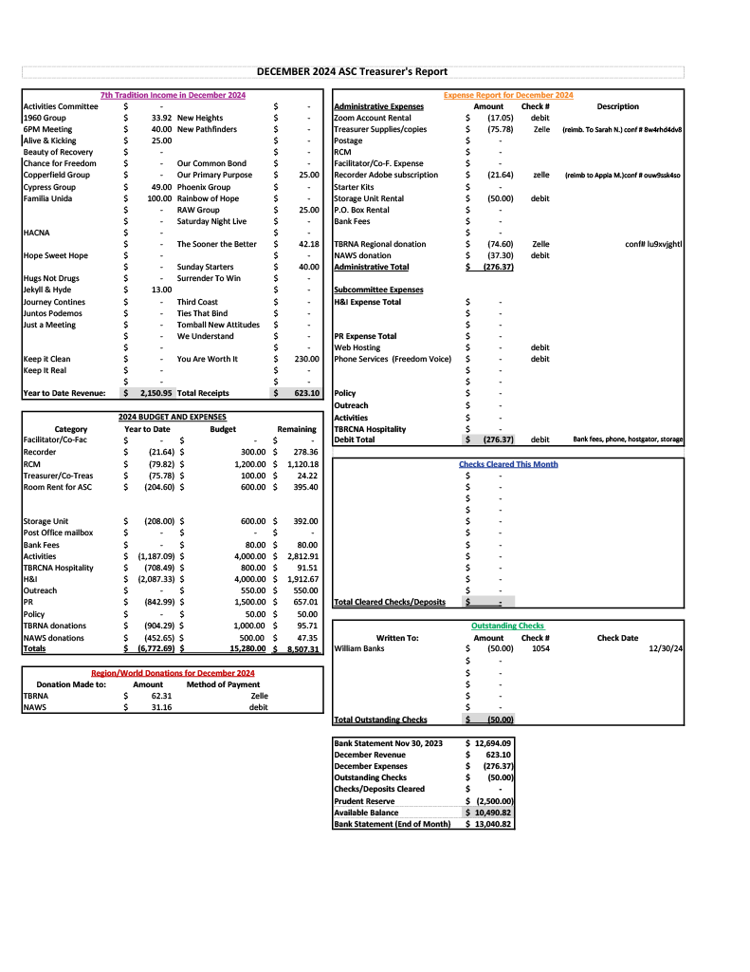
      3. 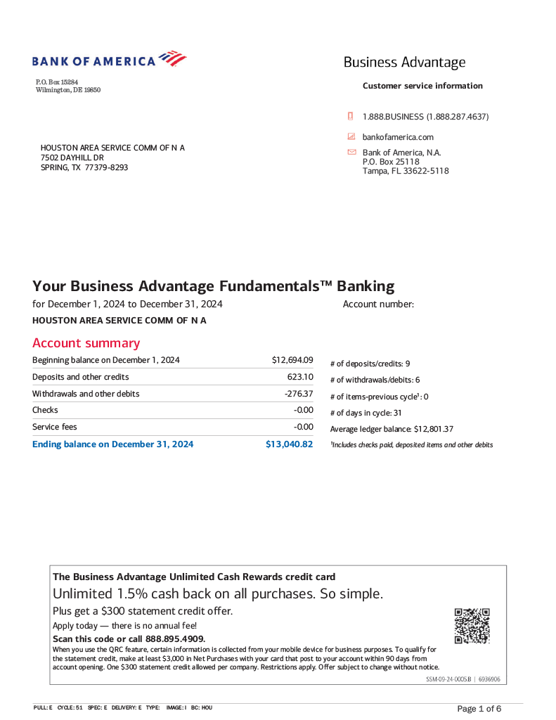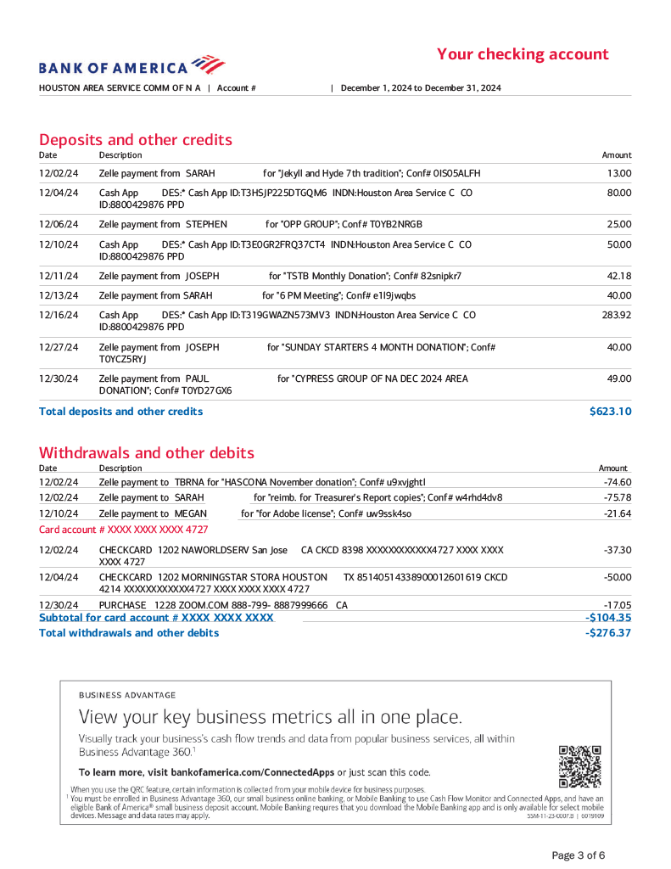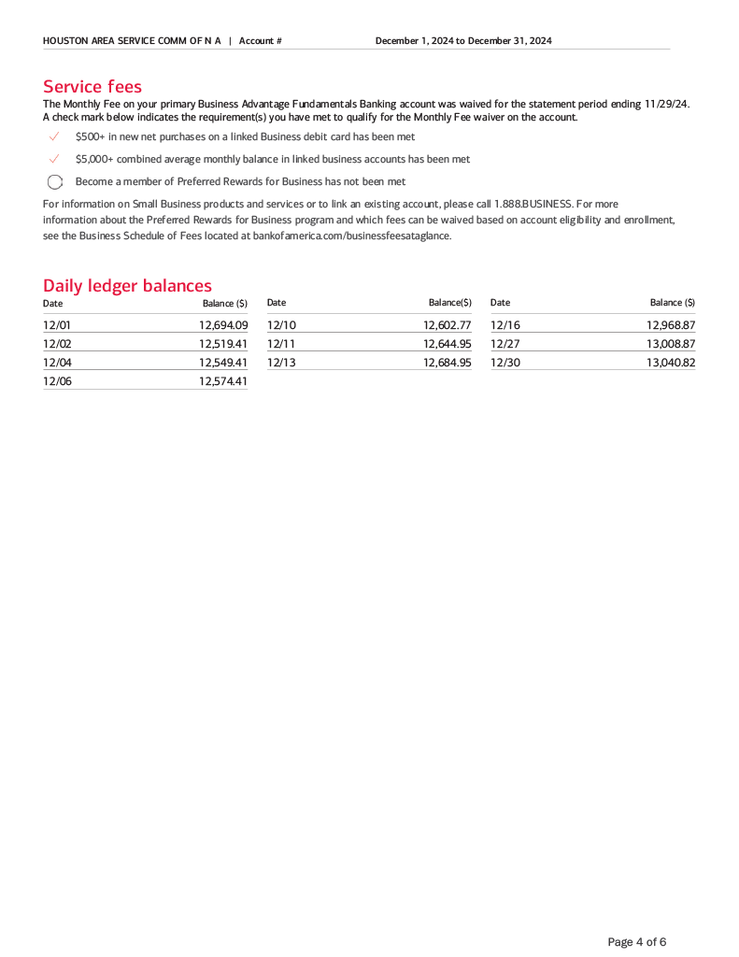
2. **Group Reports**
   1. **1960 Group - Lauren B -** GSR Lauren reports that there are no major changes at the 1960 Group. The Tuesday evening meeting still needs support. There is a new GSRA, Kelly F., who is learning from the current GSR how things run so that she will be able to assume the position when she reaches the clean time requirement in several months.
   2. **A+K - Scottie J -** Scottie reports that A&K had several well-attended events for the group, including the Christmas Day holiday feast and the New Year’s Day event. There are several events happening at the group in February, and flyers for said events will be distributed as they become available to the ASC.
   3. **Chance for Freedom - Sam G -** Sam reports that a couple of the group’s meetings are struggling, but is not specific about which meetings these are. There is nothing else of note to report.
   4. **Cypress Group - Brian N -** The group reports an ASC donation in the amount of $49. GSRA Brian N states that the group is doing well, and as such there are no changes of any kind to report. The average meeting attendance on the Sunday and Monday night meetings is between 15 and 20 recovering addicts.
   5. **Hope Sweet Hope - Tony M -** Tony is attending on behalf of the group but is clear that he is not the GSR. The group has a meeting every Thursday night at 7pm, and the meeting is hybrid, allowing for online access for those unable to attend in person. The group has decided on what they want to do for their ninth anniversary celebration. The group has also submitted a proposal, which will be introduced during new business.
   6. **Jekyll & Hyde - Rico -** The Jekyll & Hyde group is hosting a karaoke event on January 19th after a speaker meeting. The flyer will be distributed to the area upon receipt.
   7. **Juntos Podemos - Rolando M -** GSR Rolando states that the Juntos Podemos group is doing well, with an average attendance of 10 to 12 recovering addicts. Their business meeting is held on the last Friday of the month.
   8. **New Heights - Kerri M -** GSR Kerri M reports that attendance at the group has been on a downswing as of late. Otherwise she has nothing new to report.
   9. **New Pathfinders - Cameron -** The new GSR Cameron reports that the attendance for the group has been steady. Otherwise he has nothing to report, as he is new and still learning the expectations of his service position.
   10. **Outer Circle - Maria -** GSR Maria says that the average attendance for the Wednesday night meeting of the Outer Circle Group is 16 to 20 recovering addicts. The group does not currently have a group conscience meeting, but Maria plans to broach the subject with the group in the month of January.
   11. **Phoenix Group - Jason C -** Phoenix Group reports that they have been having a good month. They are still meeting on Tuesday and Thursday nights, with an average attendance of 15 to 20 people.
   12. **Rainbow of Hope - Dave V -** GSR Dave reports that the church at which Rainbow of Hope’s bi-weekly meetings have historically been held has been sold. The property has been leased back to the buyers, who will hold onto it for a year, giving the group a grace period in which they can decide whether they would like to move their meeting, and where that move will be to. The prior owners of the church have invited the group to move with them. Their meetings are Tuesday and Thursday nights, with an average attendance of 20 to 30 people on Tuesdays and 10 to 15 people on Thursdays.
   13. **Recovery at Work - Kenneth C -** GSR Kenneth says that he is trying to find out how to send in a group donation to the ASC as we no longer have a PO box. The group met for a group conscience during the holidays, although they have been unable to have their meeting as a result of prior holiday bookings at their meeting venue. Their meetings resume on Wednesday 1/8, and average 10 to 12 addicts in attendance per meeting.
   14. **The Journey Continues - Margaret M -** GSR Margaret reports that the attendance at TJC is steady, and that they are still meeting for their regular Tuesday, Thursday, and Saturday afternoon meetings. Otherwise she says there is nothing to report.
   15. **The Sooner the Better - Hector D -** GSR Hector reports that the group just celebrated birthdays this past Friday, 1/3. The next birthday meeting will be held on 2/7. Hector has nothing else to report as he is still learning his role as GSR for the group.
   16. **Sunday Starters - Darryl -** GSR Darryl says there is nothing major to report. The group meets every Sunday morning at 9:30am.
   17. **Third Coast - Juan G -** The group held their annual Christmas Eve / Christmas day marathon meeting to great success. GSR Juan reports that the group has decided that they will donate any and all proceeds that came from that meeting to the TBRCNA and HACNA committees.
   18. **Ties - Holly C -** GSR Holly reports that the group hosted a birthday celebrant, Brad T, with seven years clean. She makes no other report.
3. **Subcommittee Reports**
   1. **RCM I & II - open**
   2. **H&I** - *Mateo Z* - absent, written report submitted
      1. The H&I subcommittee is currently present in five facilities:
         1. Santa Maria Hostel
         2. The Women’s Home
         3. Cheyenne Center
         4. West Oaks Hospital
            1. This is separate from the We Understand group, which meets on Wednesday evenings. The West Oaks H&I panel meets on Tuesday evenings.
         5. Virtue Recovery
      2. As discussed in both the H&I and PR subcommittees, there is support needed in order to bring the message to these facilities.
         1. In addition, more facilities are interested in hosting H&I panels in the Houston area.
      3. There is currently a flyer in circulation asking for [facilitators](https://hascona.com/wp-content/uploads/2025/01/2.png) and [chairpeople](https://hascona.com/wp-content/uploads/2025/01/1.png) for the H&I subcommittee.
         1. Panels looking for facilitators:
            1. Virtue Recovery
            2. Cheyenne Center
            3. West Oaks
         2. Panels looking for chairpeople:
            1. Santa Maria Hostel

Reach out to Appia M if interested.

* + - * 1. The Women’s Home

Reach out to Cathryn P if interested.

* + - * 1. Cheyenne Center
        2. Virtue Recovery
        3. West Oaks Hospital
      1. Facilitators are CRUCIAL for the H&I subcommittee, as they allow for communication between the facilities and the Houston area at large.
    1. The H&I subcommittee has also drawn up a budget for the 2025 year, to be submitted at the next financial subcommittee.
    2. There are several non-chair and non-facilitator positions available on the subcommittee, including recorder, co-facilitator, and treasurer.
    3. The subcommittee meeting is every third Sunday at 2:30pm, and is available to attend using [the same Zoom link as the ASC meeting](https://zoom.us/j/97943644649).
  1. **PR -** *Brian N.*
     1. There are several open positions on the PR subcommittee:
        1. Webservant—
           1. Clean time requirement of 2yrs with working knowledge of the twelve steps, traditions, and concepts. Webservant must have previous area service experience and the resources to fulfill duties assigned by the service body. Including providing a monthly Webservant report to the PR subcommittee.
           2. Technical experience required; Understanding of the BLMT workflow and the ability to coordinate with the host server to make additions and changes as needed to the HASCONA domain site on behalf of PR subcommittee as required by the Houston Area Groups. Familiarity with WordPress, YAP and TWILLO to assist with phoneline scheduling is a plus.
           3. *Current Webservant can support with orientation*.
        2. PR Recorder—
           1. Clean time requirement of six months, active participant at the homegroup level, currently working with an NA sponsor.
           2. Technical experience required; Must be able to capture recordings of the subcommittee and provide a digital report to the service body and assist in facilitating virtual meetings.
     2. There are subcommittees working directly with PR:
        1. Phoneline—Ryan C
           1. “The current phone line coordinator is actively scheduling participants via YAP and has produced a flyer seeking volunteers to increase the bench strength of phoneline support.”
        2. Outreach—Cathryn P
           1. “The committee meets on the fourth Sunday of each month via Zoom. For outreach calendar please reach out to Cathryn.”
     3. Brian N. reports that the PR subcommittee is looking forward to the upcoming financial subcommittee, as well as hearing the proposal that has been brought to the table today.
     4. As this was brought up during the GSR reports, Brian N. takes a moment to passing Kenneth C (Recovery At Work) information on making sure they are adequately and accurately represented on the online and physical HASCONA schedule, as well as sharing details on that process with anyone else who needs to give updates to their meeting times, dates, or locations on digital and printed schedules.
     5. Brian N., with the help of the PR subcommittee and the handbook on PR issued by NAWS, developed a PowerPoint presentation on how PR presentations to local facilities should be run.
     6. The monthly PR subcommittee meeting is held on the third Sunday of the month at 1:30pm, and is available to attend using [the same Zoom link as the monthly ASC meeting](https://zoom.us/j/97943644649).
  2. **Activities - open**
  3. **Outreach** - Cathryn P
     1. The Outreach subcommittee attended three meetings in the month of December.
     2. They are scheduled to attend four meetings in the month of January:
        1. We Understand, Wednesday January 8th at West Oaks Hospital
        2. New Pathfinders, Monday January 13th
        3. Basic Recovery, Friday January 24th
        4. Copperfield Group, Friday January 31st
     3. Facilitator Cathryn is looking for more members to commit to the Outreach subcommittee.
     4. She reports that the subcommittee is looking forward to printing t-shirts for those who are of service.
     5. Brian N. attended the monthly Outreach subcommittee meeting to coordinate the remaining allotment of literature meant to go to the Houston area groups.
     6. The monthly meeting of the Outreach subcommittee meeting is on the fourth Sunday of every month, and is available to attend using [the same Zoom link as the monthly ASC meeting](https://zoom.us/j/97943644649).
  4. **Policy** - Reginald
     1. Policy facilitator Reginald reports that there are still policy changes that need to be made and followed up on.
     2. The last policy subcommittee meeting had low attendance and was unable to get the things done that facilitator Reginald intended to get done.
     3. The monthly HASCONA policy meeting is held on the first Sunday of every month, on the same day as the ASC, at 6pm. It is available for attendance using [the same Zoom link as the monthly ASC meeting.](https://zoom.us/j/97943644649)
  5. **HACNA** - Julian H
     1. The HACNA committee is now offering tickets for the traditional Saturday night pre-speaker banquet. The cost of the banquet tickets is $55.
     2. The committee is looking for individual groups in the Houston area to commit to the hospitality suite during the convention. If your group is interested, please reach out to Julian H.
     3. The HACNA committee is seeking Serenity Keepers for the convention.
     4. Juan G. has been voted in as co-programmer to maintain the HACNA site until the convention’s occurrence in September.
     5. The cost of registration has gone up from $20 to $25 as of 12/31.
     6. The monthly meeting of the HACNA committee occurs every second Sunday at 10:30am. The meeting is held at 2305 McGowan.

1. **Old Business**
   1. TBRCNA - The Houston area has agreed to hosting the hospitality suite on Friday night, taking the slot that lasts from 5pm-8pm.
      1. There is an ad-hoc committee for the hospitality suite during TBRCNA, which will be headed up by Ronnie H., HASCONA chairperson.
      2. Justin O (visiting from Hope Sweet Hope) makes an inquiry as to what the budget for HASCONA’s hospitality suite will be.
         1. Sarah N., treasurer, clarifies that the budget is $800.
      3. The TBRCNA hospitality suite ad-hoc committee will meet Sunday 1/12 at 3pm, and will be available to attend using [the same Zoom link as the monthly ASC meeting](https://zoom.us/j/97943644649).
2. **New Business**
   1. Proposal - Hope Sweet Hope - Justin O presenting
      1. 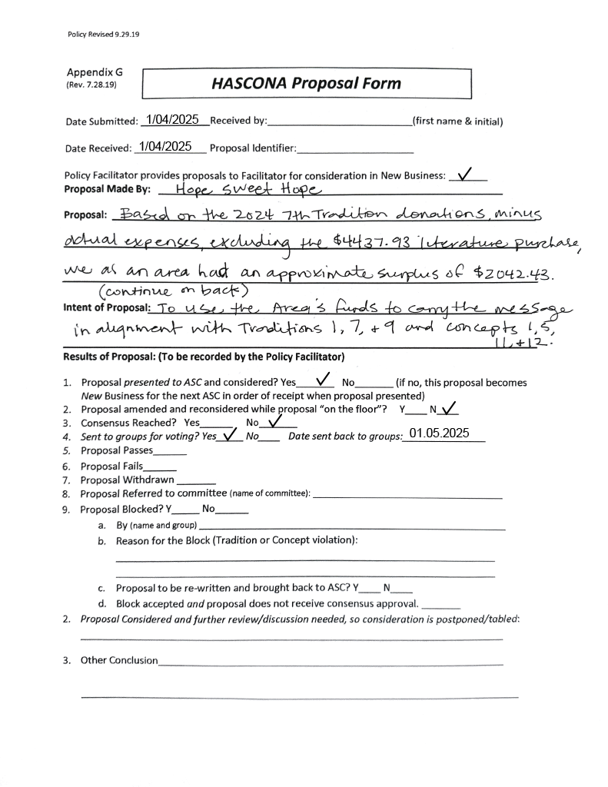
      2. 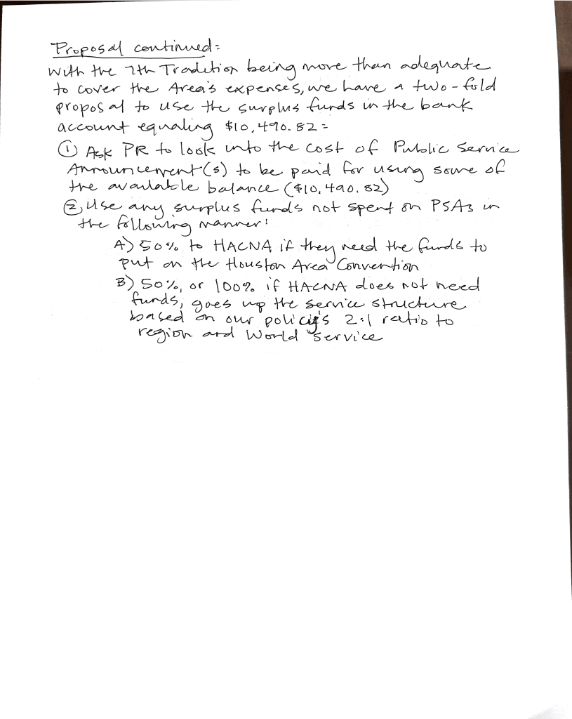
         * 1. Sarah N:

NAWS has PSAs on tap, per Margaret H.

Posits that HACNA does not need this money because they carry the message to those who are already members.

* + - * 1. Brian N:

HASCONA has created PSAs before

This has not been made part of the archive

Moving forward we should be archiving these for future ASCs that wish to distribute PSAs in the Houston area

What is the most prudent and effective way of carrying the message?

* + - * 1. Julian H:

Not sure what funds HACNA actually needs

We NEED to get rid of this money, as this has been happening for several years

* + - * 1. Ronnie H:

The consensus is that we need to get rid of this money with unity in mind

Do we want to make a bid to NAWS to host a World convention in Houston?

Growth projection of NA in cities where World has been held

Make a bid for a future WCNA

* + - * 1. Dave V:

What will the PSAs look like? Who is responsible for coordinating those?

This is Brian N’s responsibility to coordinate with the other two PR chairs in NASCONA and TCANA.

* + - * 1. Justin O:

AA has PSAs. We should also have PSAs.

Other options are there for using that money because we want to ensure that the money is actually spent

* + - * 1. Ronnie H:

We need to bring this back to the groups UNLESS we can speak to our groups’ conscience confidently today

* + - * 1. Brian N:

We have time before HACNA

We don’t see a lot of newcomers at conventions

Do we want a billboard for HACNA?

(Privately, Recorder Appia M. thinks that “Houston, we have a convention” would be such a sick tagline.)

* + - * 1. Sarah N:

Amendment to 2B of proposal: 2:1 ratio of donation to NAWS and TBRNA

We donate anything that HACNA does not need to NAWS and TBRNA

Our area is NOT struggling for money, neither is TBRNA, but NAWS is

Amendment of 75% or 100% to NAWS

* + - * 1. Ronnie H:

Areas have gotten billboards, bus signs, posters in hospitals, etc, all displaying the phone line number

We do not have a consensus on making a decision today

* + - * 1. Sam G: What will PSAs look like?
        2. Brian N:

HASCONA website has all the links to all the subcommittee meetings

If someone wants to do stuff that has to do with a subcommittee, they should find that subcommittee on the website meeting listing

Newer members willing to do service should familiarise themselves with the HASCONA site in order to know when these subcommittees meet

* + - * 1. Scottie J:

This is a really exciting really efficient way to distribute info on the Houston area in the online sphere

* 1. Sam G, Chance for Freedom: Can we put the phone line number on our schedules?
     1. Brian N:
        1. The phone number is on the schedule on the inside back flap
           1. We also have other TBRNA phone lines (e.g., TCANA, NASCONA)

1. **Open discussion**
   1. Reginald:
      1. PR did have funds to put up bus line advertisements.
      2. PSAs were also put into parole offices.
      3. What happens with that now?
         1. Ronnie H:
            1. We didn’t have a PR chair for a few years and as such the continuity of the work has been broken.
            2. More and more people are getting involved in area-level service, making opportunities for growth.
         2. Brian N:
            1. We have been putting in the work to keep the essentials (phone line, website) running.
            2. We are now slowly becoming able to do the ‘extra’ or non-essential stuff done to re-establish NA’s presence in the area.
            3. We really need people to coordinate with H&I in order to carry the message in that way too.
         3. Ronnie H:
            1. Subcs need to make commitments.
            2. Commitments need to be kept for continuity of community in non-meeting spaces, like H&I facilities and PR opportunities.
         4. Sam G:
            1. H&I facilitator for 3 years at Cenikor.
            2. People could not be counted on to keep their commitments, and as such that H&I panel was unable to continue on.
2. **Review of Business**
   1. Financial proposal to disburse excess funds being brought back to groups.
3. **Next ASC Meeting**
   1. The next ASC meeting will be held on 2/2/2025 at 10:30am.
4. **Meeting adjourned** at 12:06pm with a moment of silence, followed by the Third Step Prayer.

In grateful service,  
  
Appia M  
recorder@hascona.com