1. **Meeting opened** at 10:31am with a moment of silence followed by the Serenity Prayer.
   1. Readings:
      1. 12 Traditions - Sarah N
      2. 12 Concepts - Hurshell C
      3. Service Prayer - Rolando G
2. **Roll Call**

|  | **11/3/2024** | | | **10/6/2024** | | | **9/1/2024** | | |
| --- | --- | --- | --- | --- | --- | --- | --- | --- | --- |
| **GROUP** | **Present** | **Absent** | **right to vote?** | **Present** | **Absent** | **right to vote?** | **Present** | **Absent** | **right to vote?** |
|  |  |  |  |  |  |  |  |  |  |
| **Facilitator** | **X** |  |  | **X** |  |  |  |  |  |
| **Co-Facilitator** | **OPEN** | **OPEN** | **OPEN** | **OPEN** | **OPEN** | **OPEN** | **OPEN** | **OPEN** | **OPEN** |
| **Recorder** | **X** |  |  | **X** |  |  |  |  |  |
| **Treasurer** | **X** |  |  | **X** |  |  |  |  |  |
| **Co-Treasurer** | **OPEN** | **OPEN** | **OPEN** | **OPEN** | **OPEN** | **OPEN** | **OPEN** | **OPEN** | **OPEN** |
| **RCM 1** | **OPEN** | **OPEN** | **OPEN** | **OPEN** | **OPEN** | **OPEN** | **OPEN** | **OPEN** | **OPEN** |
| **RCM 2** |  | **X** |  |  | **X** |  |  | **A** |  |
| **H&I** | **X** |  |  | **X** |  |  |  | **A** |  |
| **PR** | **OPEN** | **OPEN** | **OPEN** | **OPEN** | **OPEN** | **OPEN** | **OPEN** | **OPEN** | **OPEN** |
| **Phoneline** | **OPEN** | **OPEN** | **OPEN** | **OPEN** | **OPEN** | **OPEN** | **OPEN** | **OPEN** | **OPEN** |
| **Activities** | **OPEN** | **OPEN** | **OPEN** | **OPEN** | **OPEN** | **OPEN** | **OPEN** | **OPEN** | **OPEN** |
| **Outreach** |  | **X** |  | **X** |  |  |  | **A** |  |
| **Policy** | **X** |  |  | **X** |  |  |  | **A** |  |
| **HACNA** | **X** |  |  | **X** |  |  |  | **A** |  |
|  |  |  |  |  |  |  |  |  |  |
| **1960 Group** | **X** |  |  | **X** |  | **X** | **P** |  | **X** |
| **6PM Meeting** |  | **X** |  |  | **X** |  |  | **A** |  |
| **Alive & Kicking** | **X** |  |  | **X** |  | **X** |  | **A** | **X** |
| **Beauty of Recovery** |  | **X** |  |  | **X** |  |  | **A** |  |
| **Chance for Freedom** | **X** |  |  | **X** |  | **X** | **P** |  | **X** |
| **Copperfield** |  | **X** |  |  | **X** |  |  | **A** |  |
| **Cypress Group** | **X** |  |  | **X** |  | **X** | **P** |  | **X** |
| **Everyday NA** |  | **X** |  | **X** |  |  |  | **A** |  |
| **Familia Unida** | **X** |  |  |  | **X** |  |  | **A** |  |
| **Hope Sweet Hope** | **X** |  |  | **X** |  |  |  | **A** |  |
| **Hugs not Drugs** |  | **X** |  | **X** |  | **X** | **P** |  | **X** |
| **Jekyll & Hyde** | **X** |  |  | **X** |  |  | **P** |  |  |
| **Juntos Podemos** | **X** |  |  | **X** |  |  | **P** |  |  |
| **Just a Meeting** |  | **X** |  |  | **X** |  |  | **A** |  |
| **Keep it Clean** |  | **X** |  | **X** |  | **X** | **P** |  | **X** |
| **Keep It Real** |  | **X** |  |  | **X** | **X** |  | **A** | **X** |
| **New Heights** | **X** |  |  | **X** |  | **X** | **P** |  | **X** |
| **New Pathfinders** |  | **X** |  |  | **X** |  |  | **A** |  |
| **Old School Keep It Simple** |  | **X** |  |  | **X** |  |  | **A** |  |
| **Our Common Bond** |  | **X** |  |  | **X** |  | **P** |  |  |
| **Our Primary Purpose (OPP)** |  | **X** |  |  | **X** |  |  | **A** |  |
| **Outer Circle Group** |  | **X** |  |  | **X** |  | **P** |  |  |
| **Phoenix Group** | **X** |  |  | **X** |  |  |  | **A** |  |
| **Rainbow of Hope** | **X** |  |  | **X** |  | **X** | **P** |  | **X** |
| **Recovery at Work** | **X** |  |  | **X** |  |  |  | **A** |  |
| **The Journey Continues** | **X** |  |  | **X** |  |  |  | **A** |  |
| **The Sooner the Better (TSTB)** |  | **X** |  | **X** |  | **X** | **P** |  | **X** |
| **Saturday Night Live** | **X** |  |  | **X** |  |  | **P** |  |  |
| **Sunday Starters** |  | **X** |  | **X** |  |  | **P** |  |  |
| **Third Coast** |  | **X** |  |  | **X** |  |  | **A** |  |
| **Ties that Bind** | **X** |  |  |  | **X** |  | **P** |  |  |
| **Tomball New Attitudes** | **X** |  |  | **X** |  | **X** |  | **A** | **X** |
| **Wednesday Night Literature Study** | **X** |  |  | **X** |  |  |  | **A** |  |
| **We Understand** |  | **X** |  |  | **X** |  |  | **A** |  |
| **W/ Grace & Gratitude** |  | **X** |  |  | **X** |  |  | **A** |  |
| **You Are Worth It** | **X** |  |  | **X** |  | **X** |  | **A** | **X** |

* 1. **New Meetings & GSRS:** N/A

1. **Key Admin Reports**
   1. **Facilitator’s Report** - Hospitality for TBRCNA?
   2. **Treasurer’s Monthly Report and Bank Statement**
      1. Financial subcommittee.
         1. Next financial subcommittee will take place on2/2/2025.
         2. Hurshell C inquires after the size of certain budgets, such as H&I and PR, given that they will have a great proportion of their allotted funds left at the end of this year.
            1. PR does webhosting and schedule printing, but has a budget cut; there is no PR chair and therefore no one available to speak for PR in terms of what their fiscal needs might be before the end of the year.
            2. H&I subcommittee chair states that H&I is getting more involved with more facilities in the Houston area, which might necessitate more funds allotted to them in the future, but ultimately agrees to a budget cut.
            3. Why were these high budgets approved for these subcommittees?

Typically this is discussed at the financial subcommittee that takes place in the new year; this can be discussed at the next financial subcommittee that will be taking place in February 2025.

* + - 1. Can we get more schedules printed with the remaining PR budget?
         1. There are several groups requesting new, updated schedules; recorder Appia M points out that Ian S from TSTB, who is not in attendance, was asking after new updated schedules at the last ASC.
         2. Again, these adjustments can be revisited at the February 2025 financial subcommittee.
    1. 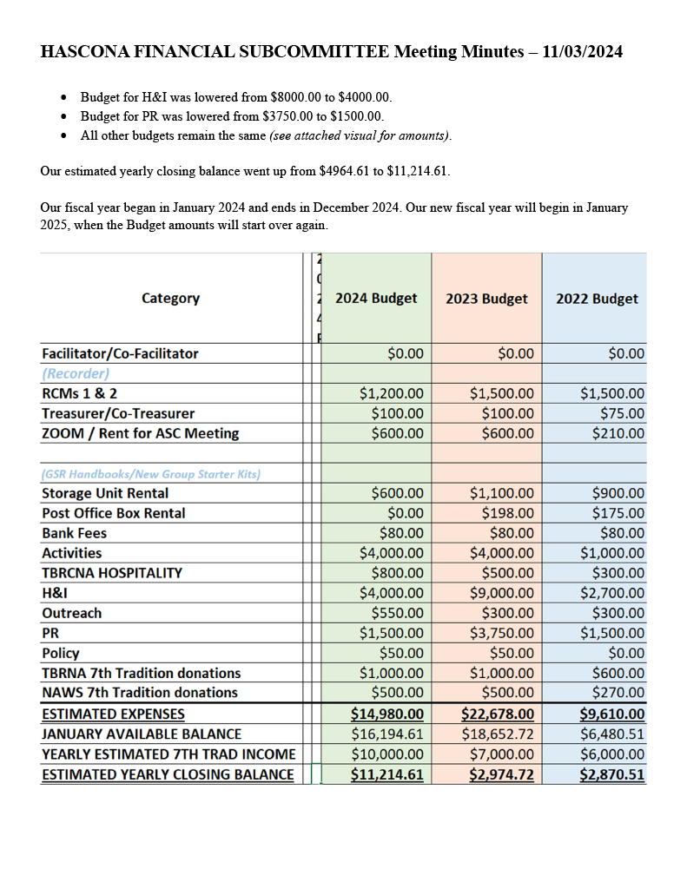
    2. 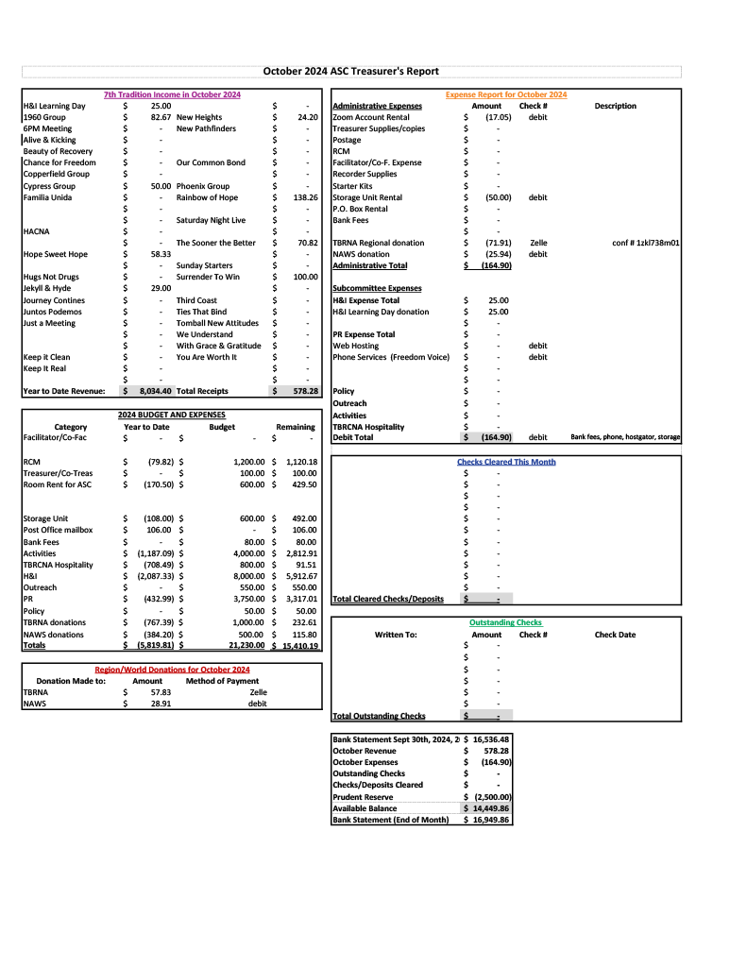
    3. 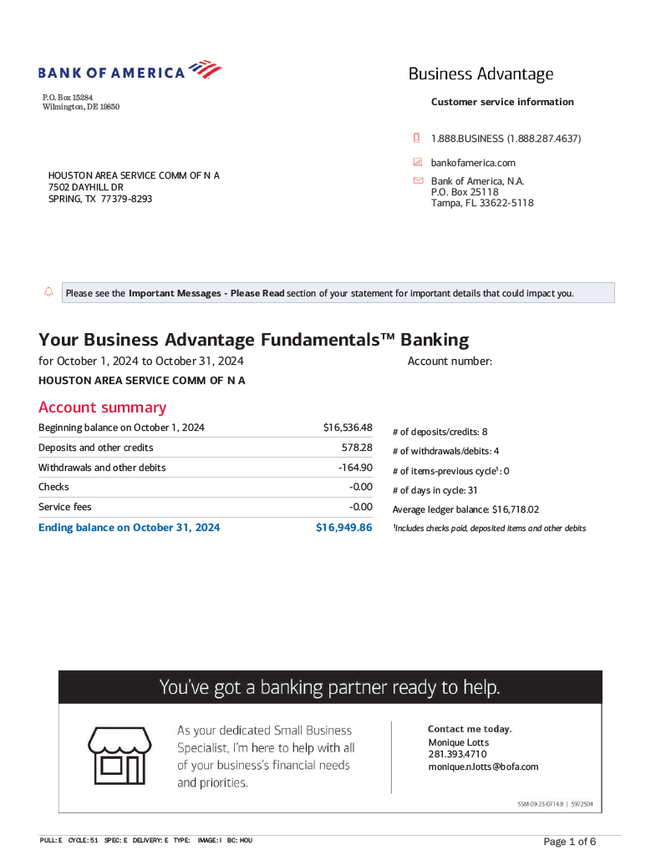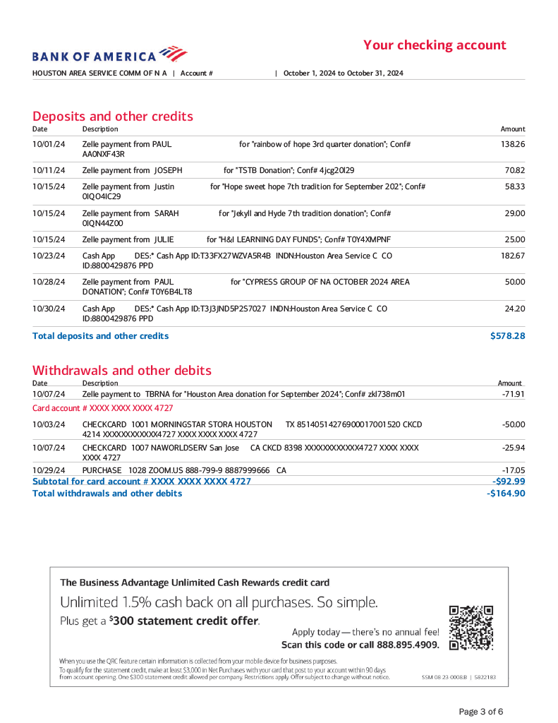

1. **Group Reports**
   1. **1960 Group - Lauren B -** GSR Lauren B reports no major changes in schedule, and states that the group’s Tuesday 6:30pm meeting needs additional support.
   2. **Alive & Kicking - Scottie J -** GSR Scottie J states that there is a Fall Festival happening on Thanksgiving day, and that there will be speakers and food for the holiday. A&K recently celebrated their 51st anniversary, which Scottie reports went well.
   3. **Chance for Freedom -** GSR Sam G states that there is nothing to report except that he cannot make Area donations because there is no PO box to which he can send a check.
   4. **Cypress Group - Ryan S -** GSR Ryan S reports that the Cypress group has made an Area donation of $50. He states that the Sunday and Monday 8pm meetings average 15 people in attendance. The group’s members observed three birthdays in October: Brian, Sarah, and Carmen.
   5. **Familia Unida - Mary R -** Familia Unida requires a schedule correction in that they have a meeting every Friday at 7pm; despite numerous attempts to correct this, the schedule still has this entry missing. GSR Mary R reports that every last Friday of the month is a birthday celebration with a group potluck. The group’s attendance is in flux, with anywhere from 5-30 addicts in attendance. GSR Mary R is asking for community support for this meeting.
   6. **Hope Sweet Hope - Tony M -** GSR Tony M reports that the Hope Sweet Hope group is still meeting every Thursday at 7pm. The meeting is located at 16755 Southwest Fwy, Sugar Land, TX, 77479. He says there is nothing more to report.
   7. **Juntos Podemos - Rolando G -** GSR Rolando states that the Juntos Podemos group is still meeting on Tuesdays from 7:30pm-9pm, and on Fridays from 8pm-9pm. The meeting is located at 13131 Fry Rd, Cypress, TX, 77433. He says that there are an average of 10-12 people per meeting. The group has nominated a new GSR for the Spanish-speaking area (Henry); email sent in report. Donation of $30 to Area.
   8. **New Heights - Kerri M -** GSR Kerri M states that there is nothing to report. Attendance is slowing down, with an average of 11-12 attendees per meeting. The New Heights group made an Area donation in the amount of $24.20.
   9. **Phoenix - Jason -** GSR Jason states that the Phoenix group is still meeting on Tuesdays and Thursdays at 7:30pm. The location of the meeting is 16000 Rippling Water Dr, Houston, TX, 77084. Pat and James celebrated in October. Next Thursday, November 7th, Mike K is celebrating 29 years.
   10. **Rainbow of Hope - Dave -** The Rainbow of Hope group’s meetings are still going strong, with 20-30 attendees at the Tuesday meeting and 10-20 meetings on the Thursday meeting.
   11. **Recovery at Work - Kenneth C -** The Recovery at Work group is a literature study that takes place from 6:30pm-8pm on Wednesdays. The meeting is located at 4925 Griggs. There is an average of 10-12 attendees per meeting.
   12. **The Journey Continues - Terri -** GSR Terri states that the Journey Continues is still meeting on Tuesdays, Thursdays, and Saturdays at 12pm. The location of the meeting is at 4203 Avenue H, Suite 11, Rosenberg, TX, 77471. There are 10-12 attendees on average.
   13. **Saturday Night Live - Joseph A -** Nothing to report.
   14. **Ties - Denny C -** Denny C states that the Ties that Bind meeting is still meeting at Terrace United Methodist Church, which is located at 1203 Wirt Rd. The meetings take place on Sunday at 7:30pm, Tuesday at 7:30. In addition, Sammy started a Basic Text meeting that meets on Monday at 7:30.
   15. **Tomball New Attitudes - Hurshell C -** TNA recently held a birthday night which hosted 7 celebrants. The group hosts Speak and Eat every second Friday. Evony M will be speaking for the month of November. The address for the meeting is715 Carrell St, Tomball, TX.
2. **Subcommittee Reports**
   1. **RCM I & II** - absent
   2. **H&I** - *Mateo Z*
      1. The H&I committee is working on the processes to get into the following facilities:
         1. Harris County Jail (pending interview with all candidates willing to bring in the message).
         2. Virtue Recovery.
         3. West Oaks Hospital.
      2. There are several positions open on the H&I committee.
         1. Facilitator for Santa Maria (female).
         2. Facilitator for Cheyenne Center (male).
         3. Recorder.
      3. Cathryn P has been nominated by the committee as well as the facility itself to take over facilitating the H&I meeting at The Women’s Home.
   3. **PR - open**
      1. **Phone Line - open**
      2. **Webservant - open**
   4. **Activities - open**
   5. **Outreach** - *Cathryn P* - absent. The report submitted is as follows:
      1. The Outreach subcommittee will be attending three meetings for the month of November:
         1. Just in Time on 11/2 at 12pm, The Council on Alcohol & Drugs, 303 Jackson Hill Street, Houston, TX, 77007.
         2. Hope Sweet Hope on 11/21 at 7pm, Sugar Land Baptist Church, 16755 Southwest Fwy, Sugar Land, TX, 77479.
         3. We Do Recover on 11/29 at 7pm, Oak Forest Church, 1216 Bethlehem St., Houston, TX, 77018.
      2. The next Outreach subcommittee meeting will be held on Sunday, 11/24 at 2pm, [using the same Zoom link as the ASC](https://zoom.us/j/97943644649).
   6. **Policy** - Reginald
      1. No report made.
      2. Policy subcommittee meets every first Sunday—the same day as the ASC meeting—at 6pm, [using the same Zoom link as the ASC](https://zoom.us/j/97943644649).
   7. **HACNA** - Julian H
      1. The HACNA committee is hosting a fundraiser: a Friendsgiving on November 23rd at We Do Recover.
         1. Oak Forest Church, 1216 Bethlehem, Houston, TX, 77018.
         2. There will be two speakers in attendance at the meeting (CJ from A&K and Barbara from San Antonio).
      2. The HACNA committee is accepting suggestions for speaker tapes. All recordings or suggestions should be emailed to [Hurshell C](mailto:hurshellcox@gmail.com).
      3. There have been two new trusted servants accepted to the HACNA committee.
         1. Samantha H was accepted as recorder.
         2. Karl T accepted as policy.
      4. Keep eyes and ears peeled about auditions for a play, hosted by and put on during HACNA.
      5. The HACNA subcommittee meets every second Sunday at 1030a. The in-person subcommittee location is at 2305 McGowan.
3. **Old Business**
   1. Three literature proposals:
      1. 1960 provided 2 proposals:
         1. Purchase two Basic Texts and It Works: How and Why, as well as one of every other text for all the groups.
         2. The total cost of the proposal would come to $4733.
            1. 8 votes
         3. Purchase 1 of every text for all the HASCONA groups.
         4. The total cost of the proposal would come out to $3669.
            1. 1 votes
      2. Rainbow of Hope provided 1 proposal:
         1. Purchase 3 Basic Texts and 3 Stepworking Guides for every HASCONA group.
         2. The total cost of the proposal would come to around $2500; no one was willing to provide an exact figure.
            1. 2 votes
         3. Dave V (Rainbow of Hope’s GSR) requested that the proposal be dropped so that he could amend it at the meeting for a re-vote.
            1. Facilitator Ronnie H states that the group’s proposal cannot be amended on the fly; instead it must be remade and re-presented in an official capacity, and rules that all the provided proposals will be going to voting
      3. Further discussions on literature proposals from October 2024
         1. Dave V originally wanted to drop the proposal and provide a new one, but refused to rescind the group’s proposal after learning that he cannot amend the provided proposal on the spot.
      4. Rolando wants the Spanish-speaking groups to get Spanish-language texts.
         1. Recorder Appia asks GSR from Familia Unida Mary R whether or not she wants her texts provided in English or Spanish, as the group considers itself bilingual.
         2. Mary states that she wants to split her doubled-up texts (the Basic Text and the IWHW) into one each English and Spanish.
4. **New Business**
   1. TBRCNA hospitality suite
      1. As the Houston area is home to this year’s TBRCNA, facilitator Ronnie H wonders if we should ask the individual groups of the Houston area to pick up segments of the timeslot for the hospitality suite that has been allotted to HASCONA.
         1. Hurshell C points out that the area is meant to take over their timeslot, as are the rest of the areas in the region.
      2. There is a call for proposals to groups in the Houston area that anyone willing to should submit an idea as to how they would facilitate an hour in the hospitality suite for the TBRCNA.
   2. Schedule printing.
      1. Several GSRs, both in attendance and not, are wondering if it is possible to get schedules printed by the time the next ASC happens.
         1. This would make it easier to distribute schedules along with the voted-on literature that is being given to each of the groups.
         2. We can discuss this at the next PR subcommittee, which is taking place on the third Sunday at 130-3pm.
   3. Chance for Freedom does not have a way of sending an Area donation as Area no longer has a PO box to which a check can be mailed.
      1. This has been worked out between Sarah and Sam.
5. **Open discussion**
   1. Can we have written reports?
      1. Recorder Appia M states that they are struggling to verify everyone’s verbally-reported information without a written report to follow up with as well. They request that written reports from GSRs and subcommittees be submitted monthly by the Friday before the next ASC meeting.
      2. There is no report for subcommittee heads.
         1. A report will be created.
   2. Can the recorder send out subcommittee info?
      1. This is all available on the HASCONA website.
      2. Recorder Appia M points out that they do include this information on the monthly minutes whenever it is given to them, and that they will continue to include that information in future minutes.
   3. Can the recorder send out calendar invites for subcommittees?
      1. Treasurer Sarah N states that it is not appropriate to give more work to someone when the information is already available.
      2. Recorder Appia M will not be sending out calendar invites, but those interested in particular subcommittees are welcome to look up that subcommittee’s meeting date and time on the HASCONA website.
      3. In addition, subcommittee chairpersons are more than welcome to send out calendar invites to members of their subcommittee.
6. **Review of Business**
   1. No business needs to be brought back to the groups this month.
7. **Next ASC Meeting**
   1. The next ASC meeting will be held on 12/1/2024 at 10:30am.
      1. This will be our annual in-person ASC meeting, held at 2305 McGowan St, 77004.
8. **Meeting adjourned** at 12:32pm with a moment of silence, followed by the Third Step Prayer.

In grateful service,  
  
Appia M  
recorder@hascona.com