1. **Meeting opened** at 10:32am with a moment of silence followed by the Serenity Prayer.
   1. Readings:
      1. 12 Traditions - Appia M
      2. 12 Concepts - Sarah N
      3. Service Prayer - Ryan S
2. **Roll Call**

|  | **10/6/2024** | | | **9/1/2024** | | | **8/4/2024** | | |
| --- | --- | --- | --- | --- | --- | --- | --- | --- | --- |
| **GROUP** | **Present** | **Absent** | **right to vote?** | **Present** | **Absent** | **right to vote?** | **Present** | **Absent** | **right to vote?** |
|  |  |  |  |  |  |  |  |  |  |
| **Facilitator** | **X** |  |  |  |  |  | **P** |  |  |
| **Co-Facilitator** | **OPEN** | **OPEN** | **OPEN** | **OPEN** | **OPEN** | **OPEN** | **OPEN** | **OPEN** | **OPEN** |
| **Recorder** | **X** |  |  |  |  |  | **OPEN** | **OPEN** | **OPEN** |
| **Treasurer** | **X** |  |  |  |  |  | **P** |  |  |
| **Co-Treasurer** | **OPEN** | **OPEN** | **OPEN** | **OPEN** | **OPEN** | **OPEN** | **OPEN** | **OPEN** | **OPEN** |
| **RCM 1** | **OPEN** | **OPEN** | **OPEN** | **OPEN** | **OPEN** | **OPEN** | **OPEN** | **OPEN** | **OPEN** |
| **RCM 2** |  | **X** |  |  | **A** |  | **P** |  |  |
| **H&I** | **X** |  |  |  | **A** |  | **P** |  |  |
| **PR** | **OPEN** | **OPEN** | **OPEN** | **OPEN** | **OPEN** | **OPEN** | **OPEN** | **OPEN** | **OPEN** |
| **Phoneline** | **OPEN** | **OPEN** | **OPEN** | **OPEN** | **OPEN** | **OPEN** | **OPEN** | **OPEN** | **OPEN** |
| **Activities** | **OPEN** | **OPEN** | **OPEN** | **OPEN** | **OPEN** | **OPEN** | **OPEN** | **OPEN** | **OPEN** |
| **Outreach** | **X** |  |  |  | **A** |  | **P** |  |  |
| **Policy** | **X** |  |  |  | **A** |  | **P** |  |  |
| **HACNA** | **X** |  |  |  | **A** |  | **P** |  |  |
|  |  |  |  |  |  |  |  |  |  |
| **1960 Group** | **X** |  | **X** | **P** |  | **X** | **P** |  | **X** |
| **6PM Meeting** |  | **X** |  |  | **A** |  |  | **A** |  |
| **Alive & Kicking** | **X** |  | **X** |  | **A** | **X** | **P** |  | **X** |
| **Beauty of Recovery** |  | **X** |  |  | **A** |  |  | **A** |  |
| **Chance for Freedom** | **X** |  | **X** | **P** |  | **X** | **P** |  | **X** |
| **Copperfield** |  | **X** |  |  | **A** |  |  | **A** |  |
| **Cypress Group** | **X** |  | **X** | **P** |  | **X** | **P** |  | **X** |
| **Everyday NA** | **X** |  |  |  | **A** |  |  | **A** |  |
| **Familia Unida** |  | **X** |  |  | **A** |  |  | **A** |  |
| **Hope Sweet Hope** | **X** |  |  |  | **A** |  |  | **A** |  |
| **Hugs not Drugs** | **X** |  | **X** | **P** |  | **X** | **P** |  | **X** |
| **Jekyll & Hyde** | **X** |  |  | **P** |  |  | **P** |  | **X** |
| **Juntos Podemos** | **X** |  |  | **P** |  |  | **P** |  |  |
| **Just a Meeting** |  | **X** |  |  | **A** |  |  | **A** |  |
| **Keep it Clean** | **X** |  | **X** | **P** |  | **X** | **P** |  | **X** |
| **Keep It Real** |  | **X** | **X** |  | **A** | **X** | **P** |  | **X** |
| **New Heights** | **X** |  | **X** | **P** |  | **X** | **P** |  | **X** |
| **New Pathfinders** |  | **X** |  |  | **A** |  |  | **A** |  |
| **Old School Keep It Simple** |  | **X** |  |  | **A** |  |  | **A** |  |
| **Our Common Bond** |  | **X** |  | **P** |  |  |  | **A** |  |
| **Our Primary Purpose (OPP)** |  | **X** |  |  | **A** |  | **P** |  |  |
| **Outer Circle Group** |  | **X** |  | **P** |  |  |  | **A** |  |
| **Phoenix Group** | **X** |  |  |  | **A** |  |  | **A** |  |
| **Rainbow of Hope** | **X** |  | **X** | **P** |  | **X** | **P** |  | **X** |
| **Recovery at Work** | **X** |  |  |  | **A** |  |  | **A** |  |
| **The Journey Continues** | **X** |  |  |  | **A** |  |  | **A** |  |
| **The Sooner the Better (TSTB)** | **X** |  | **X** | **P** |  | **X** | **P** |  | **X** |
| **Saturday Night Live** | **X** |  |  | **P** |  |  | **P** |  |  |
| **Sunday Starters** | **X** |  |  | **P** |  |  |  | **A** |  |
| **Third Coast** |  | **X** |  |  | **A** |  |  | **A** |  |
| **Ties that Bind** |  | **X** |  | **P** |  |  |  | **A** |  |
| **Tomball New Attitudes** | **X** |  | **X** |  | **A** | **X** | **P** |  | **X** |
| **Wednesday Night Literature Study** | **X** |  |  |  | **A** |  |  | **A w/ rep** |  |
| **We Understand** |  | **X** |  |  | **A** |  |  | **A** |  |
| **W/ Grace & Gratitude** |  | **X** |  |  | **A** |  | **P** |  |  |
| **You Are Worth It** | **X** |  | **X** |  | **A** | **X** | **P** |  | **X** |

* 1. **New Meetings & GSRS:** Ryan S (Cypress), Parker B (Tomball New Attitudes)

1. **Key Admin Reports**
   1. **Facilitator’s Report** - Nothing to report.
   2. **Treasurer’s Monthly Report and Bank Statement**
      1. **Next financial subcommittee:** 11/3.
      2. 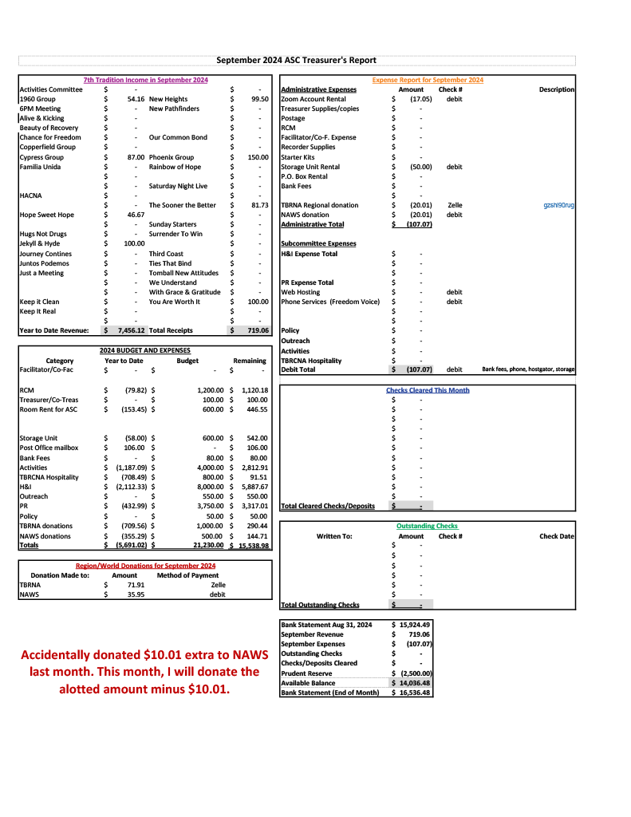
      3. 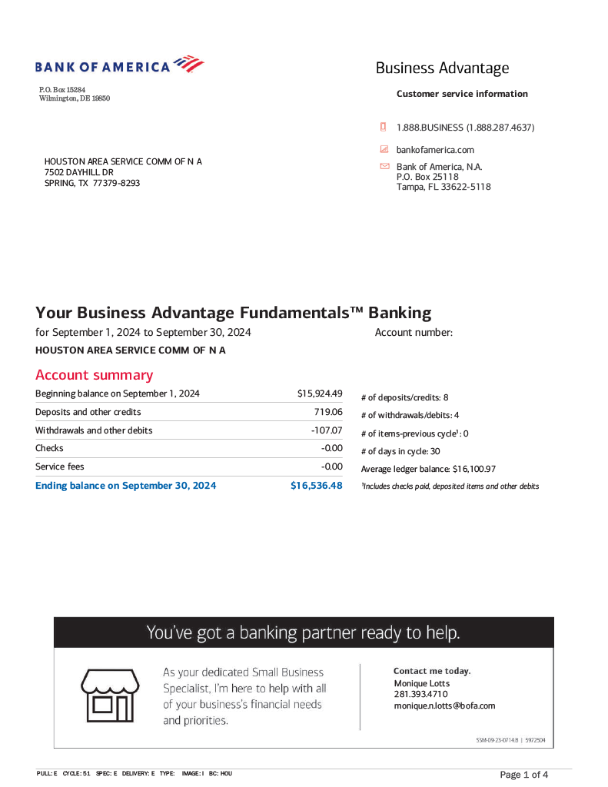  
         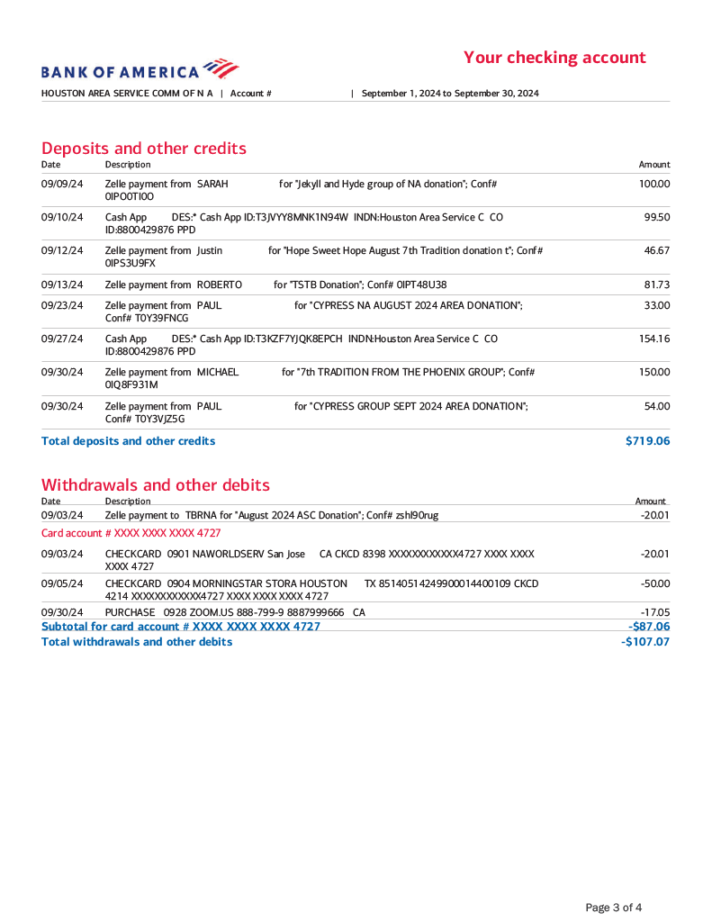
2. **Group Reports**
   1. **1960 Group - Kristine B -** Lauren B is out of town, and as such 1960 is represented by Kristine B at today’s ASC. Kristine says that there is a need for support at the 1960 Group’s Tuesday 6:30pm and Saturday 8pm meetings.
   2. **Alive & Kicking - Scottie P** - Scottie P brings a proposal that the ASC donate ten Basic Texts to A&K for their upcoming anniversary, which is taking place on October 18th and 19th. More information on the anniversary celebration can be found [on the flier here](https://imgur.com/zHO4jOS). Scottie says that the post-September 30th registration fee is $30.
   3. **Chance for Freedom - Sam G** - Sam reports that the recent anniversary celebration for Chance for Freedom went well, commemorating 33 years of the group’s history. He says that there were several celebrants for September, including several one-year celebrants, and Sam himself with 32 years. Sam is requesting a payment to the Chance for Freedom group in the amount of a $250 donation, as agreed upon at the July ASC.
   4. **Cypress Group - Ryan S -** Ryan is the new GSR for the Cypress Group. He does not have anything major to report. He has donated via Zelle in the amount of $45 to HASCONA. The meetings on Sunday and Monday are attended by an average of 10-15 people.
   5. **Everyday NA** **- Obadiah P** - Everyday NA is a new group that just celebrated its first anniversary this past September. The meetings are on Monday and Wednesday at 10am, and are attended by an average of 10-15 people.
   6. **Hope Sweet Hope - Tony M** - The Hope Sweet Hope group celebrated their 5 years’ anniversary in September.
   7. **Hugs Not Drugs - Jeffrey L -** Nothing major to report. Jeffrey says that the group celebrated three birthdays in the month of September.
   8. **Jekyll & Hyde - Roy S -** J&K had a Game Night last weekend (9/29) featuring a speaker that went well. Roy has nothing else to report.
   9. **Juntos Podemos - Rolando G -** Rolando reports that the meetings average 10-15 attendees. He mentions that there is a new GSR representing the group to the Spanish-speaking ASC. Juntos Podemos meets Tuesdays from 7:30pm to 9pm, and Fridays from 8pm to 9pm.
   10. **Keep it Clean - Justin C -** Keep it Clean meets daily at 6:30pm. Nothing to report.
   11. **New Heights - Kerri M -** Nothing to report.
   12. **Outer Circle - Maria D -** Unable to report as she was driving.
   13. **Phoenix Group - Jason C -** Jason says that there were several celebrants in the month of September, including a fifteen-year birthday and a twenty-five-year birthday. Meetings are held on Tuesday and Thursday at 7:30pm.
   14. **Rainbow of Hope - David V for David W -** David V is standing in for David W at today's ASC. Rainbow meets Tuesdays and Thursdays at 7pm. Tuesday meetings average 20-25 attendees; Thursday meetings average 10-15 attendees. The MCC where Rainbow is held is up for sale and there are no updates as to whether they will have to vacate the building as of yet. Rainbow of Hope is bringing a literature-related proposal to new business.
   15. **Recovery at Work - Kenneth C -** Wednesday 630-8p, 10-15 attendance, third anniversary on November 23rd, 5830 Van Fleet, “Our Literature Speaks When We Share Our Experience”, asking for new books for newcomers to give out at the event
   16. **The Journey Continues - Terri V -** First anniversary in September, three meetings per week, Tuesday Thursday and Saturday at noon at Fort Bend Club in Rosenberg, 9-15 in attendance
   17. **The Sooner The Better - Ian S -** There will be a Halloween outing by members and attendees of TSTB October 25th after the 8pm meeting. The outing will take place at Creepy Hollow in Rosharon. Ian S requests printed meeting schedules.
   18. **SNL - Joseph A -** Nothing to report.
   19. **Sunday Starters - Darryl -** Nothing to report.
   20. **Tomball New Attitudes -** Hurshell and Parker - There were four birthdays celebrated for the month of September. There is a Speak and Eat upcoming on Friday 10/11. Mandy from Jekyll and Hyde will be speaking. Attending members are encouraged to bring a dish to share with the group. In addition, TNA will be having their annual Halloween Bash. More details can be found [on the flier here](https://imgur.com/jrxCIj2).
   21. **Wednesday Night Literature Study - John S -** Nothing to report.
   22. **You Are Worth It - John S -** YAWI’s meetings average 30 attendees per night. John reports several birthdays celebrated in the month of September.
3. **Subcommittee Reports**
   1. **RCM I & II** - absent
   2. **H&I** - *Mateo Z*
      1. The Cheyenne Center, The Women’s Home, and Santa Maria all have meetings being brought in by the H&I subcommittee.
      2. There are several facilities reaching out that wish to have meetings brought in to them; more will be revealed regarding these conversations in future ASCs.
      3. Regarding last month’s conversation about volunteers bringing the meeting into the Harris County Jail - thanks to everyone sending in volunteer forms! Mateo says there is a direct point of contact in a coordinator within the HCJ, who will be giving him updates on volunteer applications on Monday. Any interested applicants are still welcome to apply [here](https://cscd.harriscountytx.gov/get-involved/volunteer).
         1. A question was posed about whether or not H&I is currently entering the TDCJ system.
            1. Mateo says no, and that HCJ is the first incarceration institution they will be entering.
   3. **PR - open**
      1. **Phone Line - open**
      2. **Webservant - open**
   4. **Activities - open**
   5. **Outreach** - Cathryn P
      1. Outreach attended four meetings in the month of September: Wednesday Night Literature Study, Edgebrook Unity, Rainbow of Hope, and Outer Circle.
      2. Cathryn asked the ASC at large if anyone had any information on the We Understand meeting, as it is located within the West Oaks Hospital.
         1. Someone explained that in order to gain entry one simply has to check in at the front desk.
      3. Outreach is attending three meetings in the month of October: **Beauty of Recovery** at 14540 Minetta St Houston, TX 77035 on Thursday 10/10 at 6:30pm; **Copperfield Group** at 8350 Jones Rd, Houston, TX, 77065 on Friday 10/18 at 7pm; and **The Ties That Bind** at 1203 Wirt Road, Houston, TX, 77055 on Monday 10/21 at 7:30pm.
         1. Cathryn points out that Ties’ Monday meeting is not on the online schedule.
      4. Outreach is seeking designs for a shirt for their subcommittee.
      5. The next committee meeting will be Sunday 10/27 at 2pm using [the same Zoom link as the ASC](https://zoom.us/j/97943644649).
   6. **Policy** - Reginald
      1. Reginald explains that the policy subcommittee requires support.
      2. There are changes to written policy that need to be made in order to reflect current practises in the ASC, as well as workshops that need to be announced on the HASCONA site.
      3. The policy subcommittee meets every first Sunday at 6pm using [the same Zoom link as the ASC](https://zoom.us/j/97943644649).
   7. **HACNA** - Julian H
      1. Several positions open: recorder, arts & graphics - new Serenity Keeper - pre-registrations still for sale, potential speakers, next fundraiser in November. Next committee meeting at 2305 McGowan on 10/13.
4. **Old Business**
   1. Sam G wants to discuss the annual in-person ASC meeting.
      1. Sam has secured Edgebrook Unity’s space for 11/2.
      2. Appia M - Are we going to have wifi in this meeting space?
         1. This has been given a firm no from Sam.
         2. Appia M points out that they need the wifi in order to take notes.
         3. Ronnie offers to bring his wifi hotspot.
      3. Sam G’s reasoning for bringing up the in-person ASC again is to distribute books (per the proposals listed in new business) and meeting schedules.
         1. Ryan S (Cypress) agrees and wants to ‘kill two birds with one stone’ if there’s already supposed to be an in-person ASC.
      4. Ronnie (facilitator) points out that there is no ASC consensus on the distribution of literature (per the proposals) and therefore no pressing need to make that an immediate concern.
      5. Justin (Keep it Clean) states that the ASC has been talking about where and when to have the in-person ASC for months.
      6. Several members propose 2305 McGowan due to centrality, as well as the fact that the facility has hosted previous meetings for HACNA. General consensus is that we meet on a Sunday morning. $40 to use facility. Reginald reached out to meeting space and we are scheduled for 12/1 at 1030am.
   2. Area has approved Chance for Freedom’s $250 for meeting space, as they have not received those earmarked funds.
      1. Sarah N will distribute the funds accordingly.
5. **New Business**
   1. We have no PR chair, which means that things that are necessary to HASCONA like the website, phone line, and meeting schedules have no representative or accountability.
      1. The PR subcommittee is meant to be every third Sunday using [the same Zoom link as the ASC](https://zoom.us/j/97943644649).
      2. Ronnie has volunteered to facilitate this meeting as there are no chairs for any of the relevant subcommittees.
      3. Hurshell (TNA) suggests that we make a greater effort to expeditiously fill the ASC positions that are required to keep HASCONA running smoothly.
      4. Sarah N suggests printing meeting schedules from the website provisionally until a new printing is able to be made.
      5. Cathryn P has meeting schedules for anyone asking.
         1. It is suggested that Cathryn keep her schedules as they are meant to be distributed by the Outreach subcommittee.
   2. Literature proposals
      * 1. 1960 Group, Kristine B presenting:
           1. 1960 brings two alternate proposals:

Donate 2 Basic Texts and It Works How and Why, 1 each of Guiding Principles, Step Working Guide, Just for Today, Spiritual Principle a Day to each of the groups in the HASCONA. The total cost of this proposal comes to $4,733.38, which includes shipping and discounts.

Donate one of each text to each of the groups in the HASCONA. The total cost of this proposal comes to $3,669.72, which includes shipping and discounts.

* + - 1. Rainbow of Hope - David V presenting:
         1. Many groups may have new or existing members that do not have the financial resources to purchase Narcotics Anonymous’ Basic Text or its companion, Step Working Guide. Both are necessary resources to guide addicts and their sponsors through the 12 Steps and ongoing recovery. In order to alleviate any financial barriers to begin and sustain recovery, we propose that HASCONA use its existing funds to purchase the following resources for each HASCONA group, in addition to 4 extra sets in anticipation of newly formed groups.

Rainbow proposes 3 each of the Basic Text and Step Working Guide be donated to each of the groups in the Houston area. The total cost of this proposal comes out to $2,886.66, which includes

* + 1. Reginald (Policy) wants to know if both proposals are calling for one set of these particular texts per group.
       1. This is agreed upon in all the proposals.
    2. Hurshell (TNA) wants to know if groups in the three adjacent areas (Northside, Tricounty, Freedom).
    3. Rolando (Juntos Podemos) asks: Are the groups expected to give these away at no cost? Can we have Spanish texts?
       1. Sarah N agrees that the Spanish-speaking groups should get Spanish-language texts.
       2. Sarah N also points out that once the books are donated to the groups, the groups are able to do what they want with those books and use their own discretion. They can either sell them or give them away. The ASC has no jurisdiction on the groups’ choices.
    4. Ronnie (Facilitator) explains to those who were not present for last month’s discussion on the subject that there is an excess of funds in the ASC account, and that these proposals are to divest us of these funds in accordance with our Traditions and Concepts.
    5. Sam G (Chance for Freedom) inquires as to whether or not anyone got into contact with the AAI (Adopt an Inmate) subcommittee, either through HASO or the TBRNA committee..
       1. Sarah N - Yes, but HASO is not accountable to HASCONA, and therefore they do not report in any way to HASCONA as to what they do with the funds. They donate 25 books/month to the AAI subcommittee regardless of the funding available to them, and have no system for earmarking extra funds to be given to that particular subcommittee. One letter written by an inmate gets them one book; if they ask for a Basic Text, they get a Basic Text, and so on.
          1. Brian N Cypress - HASCONA chose to adopt the AAI program from the TBRNA service committee. It is still separate. The cans’ funds do not go directly to AAI but rather to HASO or TBRNA. AAI still only gets their allotted budget.
    6. Sam G (Chance for Freedom) - How did we decide on the 44 meetings? How are we ‘governing’ who gets what?
       1. Six groups in the direct Houston area are missing or not in contact with the ASC at all.
          1. Several have been visited recently by Outreach: Edgebrook Unity, Outer Circle, Third Tradition, Surrender to Win.

With Grace and Gratitude (not present) is not meeting until they find a new location at which to meet.

* + - 1. Kristine B (1960) encourages newcomers to ask questions for clarity.
      2. Appia M (Recorder) - I Qualify is online only.
      3. Ronnie wants to clarify how to determine how we will organise this and some logistics.
         1. Justin (Keep it Clean) suggests that we take the opportunity to secure an in-person ASC to deliver things like the donation books and meeting schedules.
         2. Sam G (Chance for Freedom) agrees.
    1. Ronnie (Facilitator) suggests that rather than making a decision today, these proposals go back to the groups.
       1. Hurshell (TNA) suggests the financial subcommittee come together and combine the three proposals.
       2. Reginald (Policy) points out that, per policy, a single group must be able to take accountability for the proposal.
    2. Ronnie (Facilitator) inquires as to whether or not the GSRs feel comfortable making this decision today.
       1. A majority consensus is not reached (half of the present GSRs want to make the decision today and half don’t).
       2. The GSRs will bring the proposals back to the groups for voting at the next ASC.
  1. Literature donation proposal
     1. Scottie (Alive & Kickin) proposes ASC makes a donation of ten Basic Texts to give away to newcomers during the Clean Time Countdown at their 51st anniversary celebration, which will take place October 18th and 19th.
        1. As this cannot be brought to the groups before the next ASC, the proposal has been rejected.
  2. Literature donation proposal
     1. Kenneth RAW wants a donation of 10 Basic Texts for their anniversary on 11/23.
     2. Ronnie (Facilitator) suggests that since the anniversary is in November, that this can wait until the groups discuss the proposals brought to the table today.

1. **Open discussion**
   1. No points of open discussion.
2. **Review of Business**
   1. Literature proposals being brought back to groups.
3. **Next ASC Meeting**
   1. The next ASC meeting will be held on 11/3/2024 at 10:30am using [the HASCONA Zoom link](https://zoom.us/j/97943644649).
4. **Meeting adjourned** at 12:40pm with a moment of silence, followed by the Third Step Prayer.

In grateful service,  
  
Appia M  
recorder@hascona.com