1. **Meeting opened** at 10:37am with a moment of silence followed by the Serenity Prayer.
   1. Readings:
      1. 12 Traditions - Justin C
      2. 12 Concepts - Sam G
      3. Service Prayer - Ryan S
2. **Roll Call**

| **GROUP** | **Present** | **Absent** | **right to vote?** | **Present** | **Absent** | **right to vote?** | **Present** | **Absent** | **right to vote?** |
| --- | --- | --- | --- | --- | --- | --- | --- | --- | --- |
|  |  |  |  |  |  |  |  |  |  |
| **Facilitator** | **X** |  |  | **X** |  |  | **X** |  |  |
| **Co-Facilitator** | **OPEN** | **OPEN** | **OPEN** | **OPEN** | **OPEN** | **OPEN** | **OPEN** | **OPEN** | **OPEN** |
| **Recorder** | **X** |  |  | **X** |  |  | **X** |  |  |
| **Treasurer** | **X** |  |  | **X** |  |  | **X** |  |  |
| **Co-Treasurer** | **OPEN** | **OPEN** | **OPEN** | **OPEN** | **OPEN** | **OPEN** | **OPEN** | **OPEN** | **OPEN** |
| **RCM 1** | **OPEN** | **OPEN** | **OPEN** | **OPEN** | **OPEN** | **OPEN** | **OPEN** | **OPEN** | **OPEN** |
| **RCM 2** | **X** |  |  |  | **X** |  |  | **X** |  |
| **H&I** | **X** |  |  | **X** |  |  | **X** |  |  |
| **PR** | **OPEN** | **OPEN** | **OPEN** | **OPEN** | **OPEN** | **OPEN** | **OPEN** | **OPEN** | **OPEN** |
| **Phoneline** | **OPEN** | **OPEN** | **OPEN** | **OPEN** | **OPEN** | **OPEN** | **OPEN** | **OPEN** | **OPEN** |
| **Activities** | **OPEN** | **OPEN** | **OPEN** | **OPEN** | **OPEN** | **OPEN** | **OPEN** | **OPEN** | **OPEN** |
| **Outreach** | **X** |  |  |  | **X** |  | **X** |  |  |
| **Policy** | **X** |  |  | **X** |  |  | **X** |  |  |
| **HACNA** | **X** |  |  | **X** |  |  | **X** |  |  |
|  |  |  |  |  |  |  |  |  |  |
| **1960 Group** | **X** |  | **X** | **X** |  | **X** | **X** |  | **X** |
| **6PM Meeting** | **X** |  |  |  | **X** |  |  | **X** |  |
| **Alive & Kicking** | **X** |  | **X** | **X** |  | **X** | **X** |  | **X** |
| **Beauty of Recovery** |  | **X** |  |  | **X** |  |  | **X** |  |
| **Chance for Freedom** | **X** |  | **X** | **X** |  | **X** | **X** |  | **X** |
| **Copperfield** |  | **X** |  |  | **X** |  |  | **X** |  |
| **Cypress Group** | **X** |  | **X** | **X** |  | **X** | **X** |  | **X** |
| **Everyday NA** |  | **X** |  |  | **X** |  | **X** |  |  |
| **Familia Unida** |  | **X** |  | **X** |  |  |  | **X** |  |
| **Hope Sweet Hope** | **X** |  | **X** | **X** |  | **X** | **X** |  |  |
| **Hugs not Drugs** | **X** |  | **X** |  | **X** |  | **X** |  | **X** |
| **Jekyll & Hyde** |  | **X** | **X** | **X** |  | **X** | **X** |  |  |
| **Juntos Podemos** | **X** |  | **X** | **X** |  | **X** | **X** |  |  |
| **Just a Meeting** |  | **X** |  |  | **X** |  |  | **X** |  |
| **Keep it Clean** | **X** |  |  |  | **X** |  | **X** |  | **X** |
| **Keep It Real** |  | **X** |  |  | **X** |  |  | **X** | **X** |
| **New Heights** |  | **X** | **X** | **X** |  | **X** | **X** |  | **X** |
| **New Pathfinders** |  | **X** |  |  | **X** |  |  | **X** |  |
| **Old School Keep It Simple** |  | **X** |  |  | **X** |  |  | **X** |  |
| **Our Common Bond** |  | **X** |  |  | **X** |  |  | **X** |  |
| **Our Primary Purpose (OPP)** |  | **X** |  |  | **X** |  |  | **X** |  |
| **Outer Circle Group** |  | **X** |  |  | **X** |  |  | **X** |  |
| **Phoenix Group** | **X** |  | **X** | **X** |  | **X** | **X** |  |  |
| **Rainbow of Hope** | **X** |  | **X** | **X** |  | **X** | **X** |  | **X** |
| **Recovery at Work** | **X** |  | **X** | **X** |  | **X** | **X** |  |  |
| **The Journey Continues** |  | **X** | **X** | **X** |  | **X** | **X** |  |  |
| **The Sooner the Better (TSTB)** | **X** |  | **X** |  | **X** |  | **X** |  | **X** |
| **Saturday Night Live** |  | **X** | **X** | **X** |  | **X** | **X** |  |  |
| **Sunday Starters** |  | **X** |  |  | **X** |  | **X** |  |  |
| **Third Coast** |  | **X** |  |  | **X** |  |  | **X** |  |
| **Ties that Bind** | **X** |  | **X** | **X** |  | **X** |  | **X** |  |
| **Tomball New Attitudes** | **X** |  | **X** | **X** |  | **X** | **X** |  | **X** |
| **Wednesday Night Literature Study** |  | **X** | **X** | **X** |  | **X** | **X** |  |  |
| **We Understand** |  | **X** |  |  | **X** |  |  | **X** |  |
| **W/ Grace & Gratitude** |  | **X** |  |  | **X** |  |  | **X** |  |
| **You Are Worth It** |  | **X** | **X** | **X** |  | **X** | **X** |  | **X** |

* 1. **New Meetings & GSRS:** 
     1. **Holly C - new GSR for Ties**
     2. **Mindy A - new GSR for Third Tradition**
     3. **Hector D - new GSR for TSTB**

1. **Key Admin Reports**
   1. **Facilitator’s Report** - Nothing to report.
   2. **Treasurer’s Monthly Report and Bank Statement**
      1. Next financial subcommittee: 2/2/2025.
      2. 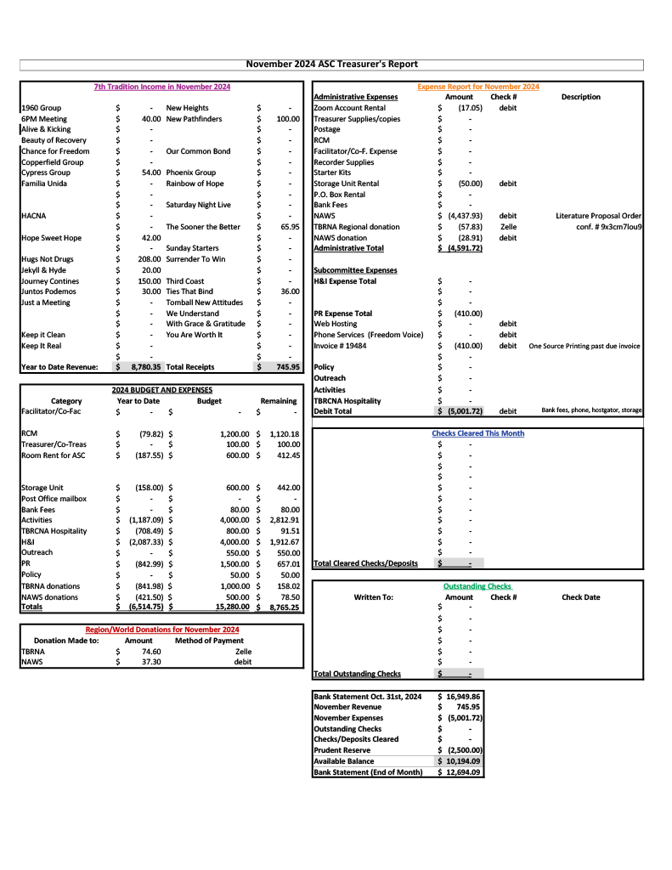
      3. 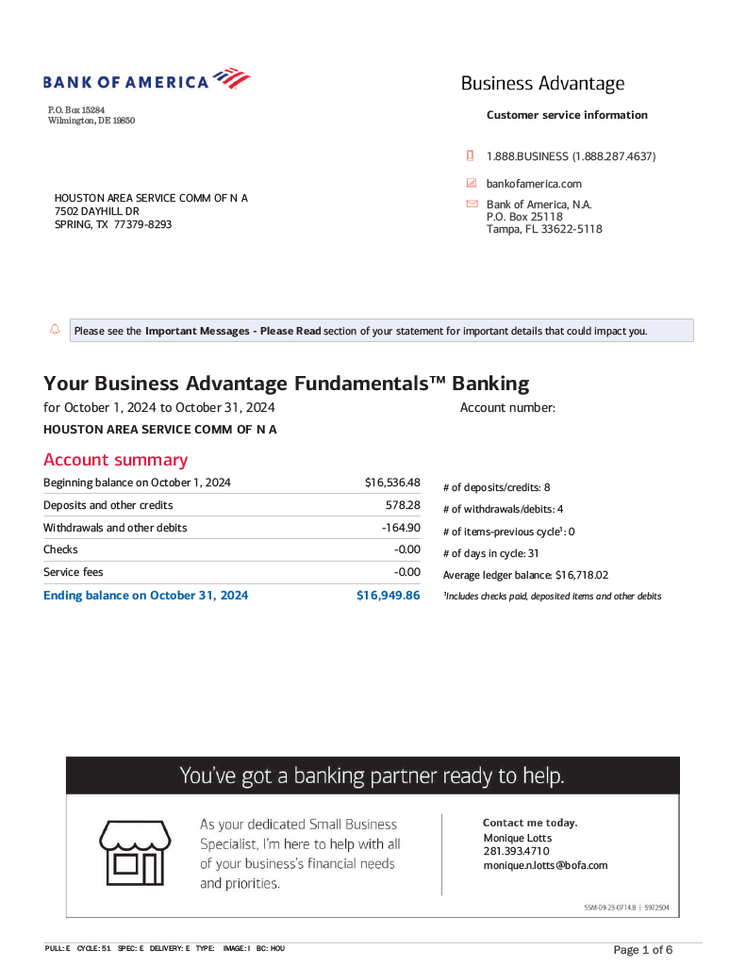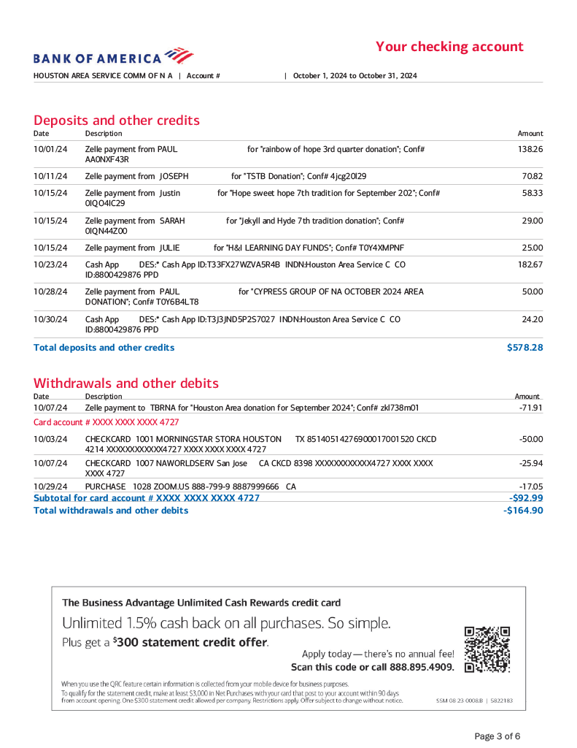
2. **Group Reports**
   1. **1960 Group -** *GSR Lauren B* - No major changes have been made to the 1960 Group. The meeting is moving back to its usual location in the downstairs parlour area, situated on the right hand side of the property, closest to the fence. The group is starting to host a speaker meeting every last Saturday of the month. The first speaker, Mallory B, was met with great success. The group still needs support at its Tuesday 6:30pm meeting.
   2. **6pm Group** - *GSR Brian R* - Nothing major to report. The group meets at the Minetta Gulf Coast Club daily at 6pm.
   3. **A&K** - *GSR Scottie* - Alive & Kickin held a Harvest Festival on Thanksgiving day that GSR Scottie reports was well-attended. The group is doing well. GSR reports there is an upcoming event on Christmas Day, the flyer for which will be forwarded at a later date.
   4. **Chance for Freedom** - *GSR Sam G* - Chance for Freedom reports that they are changing their Thursday night literature study start time from 8pm to 7pm. The group hosts four meetings a week on Thursday, Friday, Sunday, and Monday. The group’s monthly Group Conscience meets on the third Friday of every month at 6:30pm. Their monthly birthday night meeting is held on the last Friday of every month at 8pm.
   5. **Cypress** - *GSR Ryan S* - The Cypress group made a donation to the ASC this month in the amount of $54. The Cypress Group averages an attendance of 10-20 people per meeting.
   6. **Hugs Not Drugs** - *GSR Jeffrey L* - Jeffrey reports that the Thursday Night literature study is well-attended. However, he points out that the Monday and Wednesday daytime meetings require support. The group meets Mondays and Wednesdays at noon, and Thursdays at 7pm.
   7. **Juntos Podemos** - *absent, GSRa Rolando G* - A written report was submitted by GSR Rolando. The group reported excitement over receiving literature from the ASC, which was brought to them by Brian N. Their great success this month was welcoming two newcomers. The group also elected a Spanish-speaking GSR, Hendry, to the Spanish-speaking Region. The group meets for conscience every first Friday.
   8. **Keep it Clean** - *GSR Justin E* - The Keep it Clean group reports no major changes, and that they meet every day at 6:30pm in Baytown. The group’s monthly group conscience is held on the second Saturday of every month, and their monthly birthday potluck happens every third Sunday from 5:30 to 7:30pm.
   9. **Phoenix** - *GSR Jason C* - The Phoenix Group reports no major changes or goings-on. The group meets every Tuesday and Thursday at 7:30pm.
   10. **Rainbow** - *GSR Dave V* - The Rainbow of Hope group is currently in the process of writing some bylaws for their group that will be submitted for consideration at their upcoming business meeting, which will take place on the second Tuesday of the month after their regular meeting. Their Tuesday meetings are attended by an average of 20 to 30 recovering addicts, and their Thursday meetings are attended by 10 to 15.
   11. **Recovery at Work** - *GSR Kenneth C* - The RAW Group celebrated its first anniversary on November 23rd to great success, with somewhere between 60 and 70 addicts in attendance. Kenneth took special note to mention the speakers, which he feels did a wonderful job. The group meets on Wednesday nights from 6:30 to 8pm at 4925 Griggs, and is a Basic Text literature study in which they share on one particular paragraph per meeting. There is an average attendance of 10 to 12 people pet meeting.
   12. **The Sooner the Better** - *GSR Hector D* - The new GSR Hector has nothing to report, other than that he is in fact the new GSR, and that he is learning the ropes of his service position.
   13. **Ties that Bind** - *GSR Holly C* - As the GSR Holly is new, she does not have a report to make, as she is still learning what is expected of her in her new service position.
   14. **Tomball New Attitudes** - *GSR Parker B* - This is Parker’s second time with us, and as such he is still learning the expectations of his position. The group’s attendance is in a state of flux, with anywhere from 5 to 20 addicts in attendance at their regular meetings. The group is hosting its monthly Speak & Eat on Friday, 12/13, where Ashley W will be sharing her experience, strength, and hope. They will also be hosting a Christmas event
3. **Subcommittee Reports**
   1. **RCM II** - *Henry*
      1. NAWS has put out a survey meant to be taken by NA members for demographic information.
         1. NAWS’ member demographic has not been filled out since 2018.
      2. NAWS has put out a survey about the Step-working Guide.
         1. It is possible to be done as a member, a group, or an area.
         2. NAWS is also looking to make modifications to the Step-working Guide and would like groups’ and areas’ input on these modifications.
      3. Henry is stepping down from his position as he no longer lives in the Houston area.
         1. He gives a brief explanation of the RCM position expectations.
            1. The meetings are mainly hybrid, with in-person and virtual options available.
            2. If interested in the RCM position please reach out to Henry or any ASC trusted servant.
   2. **H&I** - *Mateo Z*
      1. The H&I subcommittee will begin entering West Oaks Hospital for H&I panel.
         1. The panel will hold its first meeting on 12/10 at 7pm.
      2. The H&I subcommittee is still entering Santa Maria Jacquelyn House and The Women’s Home.
         1. A new facilitator for The Women’s Home has been elected: Cathryn P.
         2. There is an incumbent nominee as facilitator for Santa Maria Jacquelyn House: Appia M.
            1. Mateo has previously expressed hope that with a new facilitator it will be possible to restore H&I meetings to the Parker House.
      3. The H&I subcommittee needs a new male facilitator for the Cheyenne Center.
         1. The commitment is on Fridays and Sundays at 6:30pm.
         2. For more details on what qualifies a facilitator reach out to Mateo Z. directly.
      4. The subcommittee requires manpower at this time.
         1. There are several facilities in the Houston area that are not getting the H&I panels that they are requesting specifically because there are not a great number of people willing to bring the message to them.
      5. People are slowly getting accepted as volunteers for HCJ, but at present there is no ability to get in contact with the 12-Step Coordinator inside HCJ.
         1. There was someone inside the HCJ who was coordinating but he has stopped returning contact. Mateo Z. will keep trying to reach out to him.
         2. At present the subcommittee oing to need a facility coordinator for HCJ.
      6. The H&I subcommittee meets every third Sunday at 2:30pm, using [the same Zoom link as the ASC meeting](https://zoom.us/j/97943644649).
   3. **PR - open**
      1. Brian N., Cypress, has been nominated for PR chair.
         1. Brian N. was voted in.
      2. There was a PR subcommittee meeting held on 11/17.
         1. There was an order placed for new schedules as well as business cards that have QR codes that lead to the HASCONA website.
            1. The company that does the printing pointed to an outstanding invoice from the last printing, and that was paid.
            2. The new schedules and QR code cards have been distributed with the literature.
         2. The PO box address has been removed from the website, as we no longer have a PO box.
         3. Brian N. expressed interest in setting up the regular PR booth at HACNA.
            1. Jerry has this and will pass it along to Brian.
         4. There is no current phone line chair.
            1. This is covered in the ‘Phone Line’ section of these minutes.
         5. Future potential plans for the PR subcommittee include branching out.
            1. There was an expressed interest in the following:

There was once a card on the bus line that hung overhead on several buses. It came through a contract with METRO.

Teleconferences with probation and parole officers so they know what to expect when their probationers and parolees are recommended to attend NA meetings.

Another printing of the QR codes to be distributed ‘in places where addicts hang out’.

* + - 1. The next PR subcommittee meeting will be on the third Sunday at 1:30pm, using [the same Zoom link as the ASC meeting](https://zoom.us/j/97943644649).
    1. **Phone Line** - open
       1. For information on joining the Phone Line, please reach out to Ryan C. or email phoneline@hascona.com.
    2. **Webservant** - open
       1. We have Gus D. assisting with webservant needs in the interim, but the Houston area needs a full-time webservant.
    3. 3rd Sunday @ 1pm
  1. **Activities** - open
  2. **Outreach** - *Cathryn P*
     1. The Outreach subcommittee attended two meetings in the month of November:
        1. Hope Sweet Hope
        2. Just in Time
     2. The subcommittee has made plans to attend the following groups in the month of December:
        1. 1960 Group on Tuesday 12/3 at 6:30pm.
        2. Familia Unida on Friday 12/13 at 7pm.
        3. We Do Recover on Friday 12/20 at 7pm.
        4. Our Common Bond on Sunday 12/29 at 6pm.
     3. The next Outreach subcommittee meeting will occur on Sunday 12/22 at 2pm, using [the same Zoom link as the ASC meeting](https://zoom.us/j/97943644649).
  3. **Policy** - *Reginald*
     1. The last Policy subcommittee meeting was held on 11/3 to no support.
        1. Reginald is asking for HASCONA members to show up to the Policy subcommittee meeting in order to make policy change decisions.
     2. Policy changes that are on the table are as follows:
        1. The ASC meeting has not been officially changed to being on the last Sunday of every month, although that is when the meetings have been held.
        2. The bank statements for the HASCONA account will be mailed to the ASC PO box to be reviewed by, reconciled, and maintained for the purpose of record-keeping by the Area treasurer and or co-treasurer.
     3. The next subcommittee meeting will be held on Sunday 12/1 at 6pm, using [the same Zoom link as the ASC meeting](https://zoom.us/j/97943644649).
  4. **HACNA** - Julian H
     1. The last HACNA committee meeting was held on 11/10.
        1. A flyer was made advertising auditions for a play that will be performed during HACNA.
        2. Room blocks are still available via [the HACNA website](https://hacna.com).
        3. Pre-registration is still for sale.
        4. The committee is in need of Serenity Keepers in order to make sure the convention flows smoothly and without issue.
        5. The committee is seeking recommendations for speaker tapes.
        6. HACNA will be held the last weekend of September, the 26th, 27th, and 28th.
     2. The next HACNA committee meeting will take place on Sunday 12/8 at 10:30am, at the Hyatt Regency Houston West, located at 13210 Katy Fwy.

1. **Nominations**
   1. Brian N - PR
      1. Motion to vote Brian in made by Sam G (GSR, Chance for Freedom).
      2. After an exceptionally brief deliberation period, Brian was accepted as the PR chairperson.
2. **Old Business**
   1. The last ASC saw ASC members talking about what to do with the allotted time slots for the TBRCNA hospitality suites.
      1. On the February 14th and 15th dates, there are 9 total time slots available.
         1. Friday 5-8pm
         2. Friday 10pm-12am
         3. Saturday 7-10am
         4. Saturday 10am-12pm
         5. Saturday 1-4pm
         6. Saturday 4-7pm
         7. Saturday 10pm-12am
      2. Sent to Ronnie which will be sent to me
      3. 9 groups need to take on the various time slots.
         1. Tammy from TBRCNA hospitality reports that these slots need to be filled.
         2. ASC is going to take accountability for time slots, as the Houston area is hosting the convention. The following is proposed:
            1. The ASC has a budget of $800 reserved for TBRCNA hospitality.
            2. Individual groups within the Houston area come up with ideas for their time slot, supply members willing to do the service work involved, and ASC will fund them partially by divvying up the existing budget.
         3. (I believe it’s Sam G., Chance for Freedom, who asks:) Do we want to set the precedent of one area hosting the entire hospitality suite, save Sunday morning brunch (which is usually hosted by the region itself)?
            1. We don’t have the money to cover the entirety of hospitality.
            2. We can’t guarantee that every group in the Houston area will be willing or able to take a timeslot.
            3. Tammy reports that no other area has expressed interest in hosting Hospitality.
            4. Houston ASC cannot and will not be entirely responsible for hosting a hospitality suite for the entirety of the convention.

There are eight areas in the region and there should be other areas stepping up to assist.

Contact Henry to speak with other areas to see where and how they would be able to provide their own time slot for the hospitality suite.

* + - 1. Sarah N., treasurer, moves that HASCONA take responsibility for the Friday night 5-8pm time slot.
         1. Seconded by Sam G.
         2. Motion passes.

1. **New Business**
   1. Donation to facility for in-person ASC
      1. There is an inquiry about what the donation made to the Montrose Center was when the in-person ASC was held there.
      2. There is a remaining budget of $390 for the year for donations to in-person meeting locations.
      3. Sam G., Chance for Freedom, motions for a $50 donation to 2305 McGowen.
         1. Seconded by Sarah N., treasurer
   2. Newer H&I / PR facilities—online panel?
      1. Brian N mentions wanting to see more things online, including online educational panels for rehab and medical professionals, etc.
      2. This would also apply to facilities who want to see an H&I panel but we don’t have the service body available to set up a regular meeting for them.
   3. Formal monthly subcommittee report format
      1. Recorder Appia M. has drafted a report for subcommittee chairs to fill out for their monthly reports.
         1. This is approved.
         2. The new document will be sent out along with blank GSR reports and monthly minutes.
   4. Recorder budget
      1. Recorder Appia M. is paying for Adobe out of pocket at a rate of $21.65 a month and cannot really afford the out-of-pocket costs. They are asking for the yearly cost of the subscription in reimbursement from the ASC.
         1. The group motions to reimburse recorder Appia and approves a $300 annual budget for the recorder position.
2. **Open discussion**
   1. New Years’ party?
      1. Cathryn P helped host one last year at Ties and expresses disinterest in organising another one.
      2. Several members of the committee mention Ashley W. as the person to go to if the ASC wants to have a HACNA-fronted New Years’ event.
      3. At present there is no HASCONA activities chair.
      4. There is a quiet general consensus: let’s increase the amount of events we have in groups instead!
   2. Facilitator / host polls in Zoom meeting?
      1. The ASC wants to find a cleaner way to take votes virtually.
         1. At the previous ASC there was a lot of confusion because people were both raising their hands to speak and to vote at the same time.
      2. The voting process needs a change.
         1. This change would have to be approved by a Policy subcommittee.
         2. Facilitator Ronnie H. states that as chairperson he was counting nodding heads and visibly raised hands in-frame on-camera as affirmative votes.
            1. However, it is brought up by several members that this isn’t a clear demarcation of someone’s intentions, either.
      3. Henry says that this discussion was had at the RCM a year prior to this ASC meeting
         1. The RCM uses the Zoom polling feature. However, the polling is anonymous. This leads to a miscalculation in votes with some frequency.
         2. The GSRs that are voting need to be able to identify what group they are voting on behalf of. This is in part due to there being ‘voting members’ among the GSRs—that is, GSRs from groups who have attended two consecutive ASC meetings.
         3. A general motion is made for this to be brought to the policy subcommittee meeting later today.
   3. Annual in-person meeting
      1. The January ASC meeting ‘new business’ segment sets the in-person ASC meeting for a date later in the year.
         1. Should we have it every first Sunday in December, annually?
         2. Should this be a policy addition?
      2. Who can bring a proposal before the subcommittee for a potential policy change?
         1. Any member can bring a proposal to the policy committee.
         2. The policy subcommittee reviews the proposal and brings it to the monthly ASC meeting.
         3. The ASC discusses the policy proposal, and sends the decision back to the groups for voting if a consensus cannot be reached.
3. **Review of Business**
   1. Need facilitators and volunteers for H&I.
   2. Need support for the Policy subcommittee.
   3. Groups supplying manpower for hospitality on Friday 2/14 between 5 and 8pm.
4. **Next ASC Meeting**
   1. The next ASC meeting will be held on 1/5/2025 at 1030am.
5. **Meeting adjourned** at 12:29pm with a moment of silence, followed by the Third Step Prayer.

In grateful service,  
  
Appia M  
recorder@hascona.com