1. **Meeting opened** at 10:32 am with a moment of silence followed by the Serenity Prayer.
   1. Readings:
      1. 12 Traditions - Ian S
      2. 12 Concepts - Sarah N
      3. Service Prayer - Jeffrey L
2. **Roll Call**

|  | **9/1/2024** | | | **8/4/2024** | | | **7/13/2024** | | |
| --- | --- | --- | --- | --- | --- | --- | --- | --- | --- |
| **GROUP** | **Present** | **Absent** | **right to vote?** | **Present** | **Absent** | **right to vote?** | **Present** | **Absent** | **right to vote?** |
|  |  |  |  |  |  |  |  |  |  |
| **Facilitator** | **P** |  |  | **P** |  |  | **P** |  |  |
| **Co-Facilitator** | **OPEN** | **OPEN** | **OPEN** | **OPEN** | **OPEN** | **OPEN** | **OPEN** | **OPEN** | **OPEN** |
| **Recorder** | **P** |  |  | **OPEN** | **OPEN** | **OPEN** | **OPEN** | **OPEN** | **OPEN** |
| **Treasurer** | **P** |  |  | **P** |  |  | **P** |  |  |
| **Co-Treasurer** | **OPEN** | **OPEN** | **OPEN** | **OPEN** | **OPEN** | **OPEN** | **OPEN** | **OPEN** | **OPEN** |
| **RCM 1** | **OPEN** | **OPEN** | **OPEN** | **OPEN** | **OPEN** | **OPEN** | **OPEN** | **OPEN** | **OPEN** |
| **RCM 2** |  | **A** |  | **P** |  |  |  | **A** |  |
| **H&I** |  | **A** |  | **P** |  |  |  | **A** |  |
| **PR** | **OPEN** | **OPEN** | **OPEN** | **OPEN** | **OPEN** | **OPEN** | **OPEN** | **OPEN** | **OPEN** |
| **Phoneline** | **OPEN** | **OPEN** | **OPEN** | **OPEN** | **OPEN** | **OPEN** |  | **A** |  |
| **Activities** | **OPEN** | **OPEN** | **OPEN** | **OPEN** | **OPEN** | **OPEN** | **OPEN** | **OPEN** | **OPEN** |
| **Outreach** |  | **A** |  | **P** |  |  | **P** |  |  |
| **Policy** |  | **A** |  | **P** |  |  | **P** |  |  |
| **HACNA** |  | **A** |  | **P** |  |  | **P** |  |  |
|  |  |  |  |  |  |  |  |  |  |
| **1960 Group** | **P** |  | **X** | **P** |  | **X** | **P** |  | **X** |
| **6PM Meeting** |  | **A** |  |  | **A** |  |  | **A** | **x** |
| **Alive & Kicking** |  | **A** | **X** | **P** |  | **X** | **P** |  |  |
| **Beauty of Recovery** |  | **A** |  |  | **A** |  |  | **A** |  |
| **Chance for Freedom** | **P** |  | **X** | **P** |  | **X** | **P** |  | **X** |
| **Copperfield** |  | **A** |  |  | **A** |  |  | **A** |  |
| **Cypress Group** | **P** |  | **X** | **P** |  | **X** | **P** |  | **X** |
| **Everyday NA** |  | **A** |  |  | **A** |  |  | **A W/REP** | **X** |
| **Familia Unida** |  | **A** |  |  | **A** |  |  | **A** |  |
| **Hope Sweet Hope** |  | **A** |  |  | **A** |  | **P** |  | **X** |
| **Hugs not Drugs** | **P** |  | **X** | **P** |  | **X** | **P** |  | **X** |
| **Jekyll & Hyde** | **P** |  |  | **P** |  | **X** |  | **A** | **X** |
| **Juntos Podemos** | **P** |  |  | **P** |  |  |  | **A** | **X** |
| **Just a Meeting** |  | **A** |  |  | **A** |  |  | **A** |  |
| **Keep it Clean** | **P** |  | **X** | **P** |  | **X** |  | **A** | **X** |
| **Keep It Real** |  | **A** | **X** | **P** |  | **X** | **P** |  | **X** |
| **New Heights** | **P** |  | **X** | **P** |  | **X** | **P** |  | **X** |
| **New Pathfinders** |  | **A** |  |  | **A** |  |  | **A** |  |
| **Old School Keep It Simple** |  | **A** |  |  | **A** |  |  | **A** |  |
| **Our Common Bond** | **P** |  |  |  | **A** |  |  | **A** |  |
| **Our Primary Purpose (OPP)** |  | **A** |  | **P** |  |  |  |  |  |
| **Outer Circle Group** | **P** |  |  |  | **A** |  |  | **A** |  |
| **Phoenix Group** |  | **A** |  |  | **A** |  |  | **A** |  |
| **Rainbow of Hope** | **P** |  | **X** | **P** |  | **X** | **P** |  | **X** |
| **Recovery at Work** |  | **A** |  |  | **A** |  |  | **A** |  |
| **The Journey Continues** |  | **A** |  |  | **A** |  |  | **A** |  |
| **The Sooner the Better (TSTB)** | **P** |  | **X** | **P** |  | **X** | **P** |  | **X** |
| **Saturday Night Live** | **P** |  |  | **P** |  |  |  | **A** | **X** |
| **Sunday Starters** | **P** |  |  |  | **A** |  |  | **A** | **X** |
| **Third Coast** |  | **A** |  |  | **A** |  |  | **A** |  |
| **Ties that Bind** | **P** |  |  |  | **A** |  | **P** |  |  |
| **Tomball New Attitudes** |  | **A** | **X** | **P** |  | **X** |  | **A** | **X** |
| **Wednesday Night Literature Study** |  | **A** |  |  | **A w/ rep** |  |  |  |  |
| **We Understand** |  | **A** |  |  | **A** |  |  | **A** |  |
| **W/ Grace & Gratitude** |  | **A** |  | **P** |  |  |  | **A** |  |
| **You Are Worth It** |  | **A** | **X** | **P** |  | **X** | **P** |  | **X** |

* 1. **New Meetings & GSRS:** Maria, Outer Circle

1. **Key Admin Reports**
   1. **Facilitator’s Report** - nothing major to report; studying up on policy, encouraging everyone to do the same
   2. **Treasurer’s Monthly Report and Bank Statement**
      1. Next financial subcommittee meeting is 11/3; more details to come
      2. 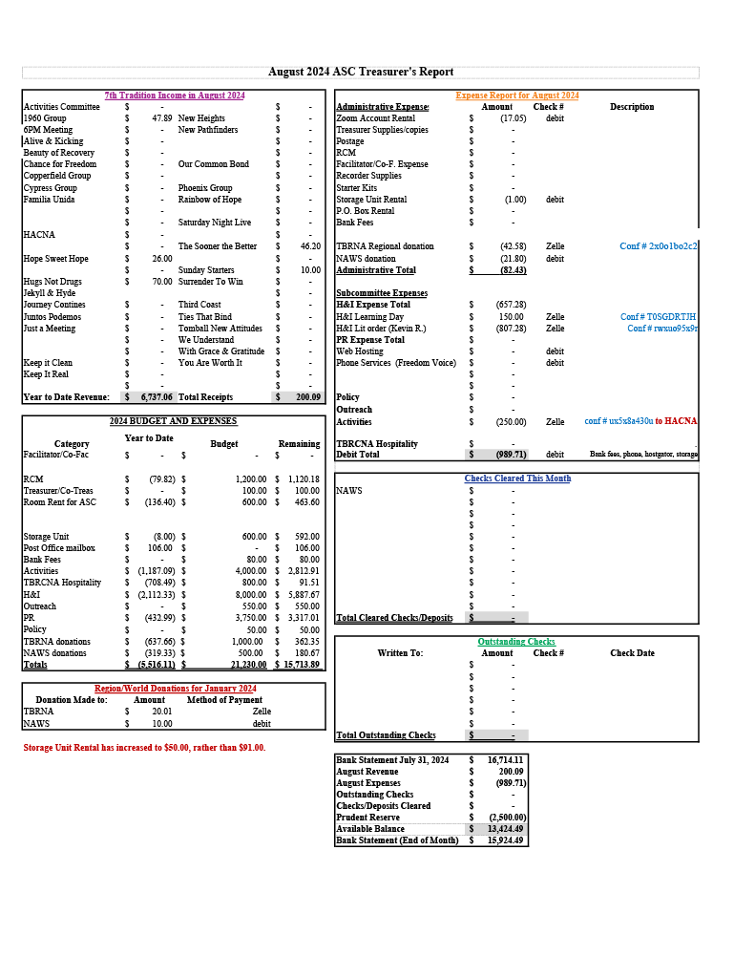
      3. 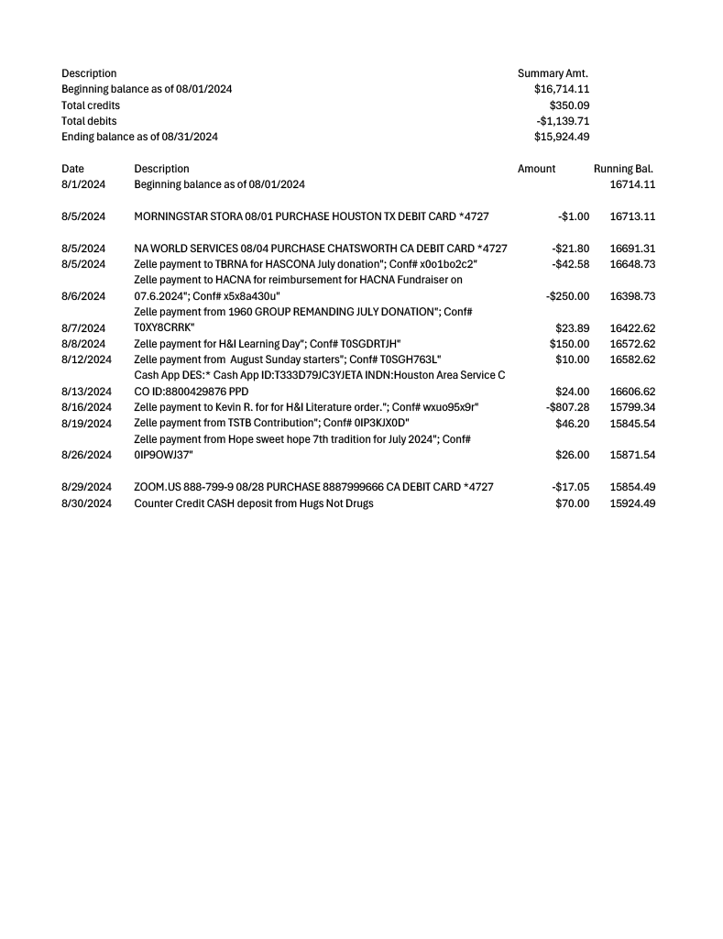
2. **Group Reports**
   1. **1960 Group** - *Lauren B* - 1960 is still searching out a new home, which they will discuss at their upcoming business meeting on 9/7. No changes otherwise.
   2. **Chance for Freedom** - *Sam* - Chance’s 33rd Anniversary celebration will take place on Saturday, 10/5 from 3-6pm. Sam made a point to explain that this will just be fun, fellowship, and games, with no speaker in attendance.
   3. **Cypress Group** - *Levi W* - Cypress Group is working on planning the Spirit of Unity Campout, dates scheduled from October 25th to the 27th. There is still more planning being done, and no further updates can be given at this time due to member absence. Cypress Group also hosted two birthday celebrants in the month of August.
   4. **Hugs not Drugs** - *Jeffrey M* - There are three upcoming birthday celebrations during the month of September. Thursday night 7pm meetings average anywhere from 12 to 30 attendees. Daytime meeting attendance is also on an upswing.
   5. **Jekyll and Hyde** - *Rico* - There have been no schedule changes. J&H is hosting a game night on Sunday 9/29 at 5pm, including a speaker meeting.
   6. **Juntos Podemos** - *Rolando* - Juntos reports no changes in schedule, and meets Tuesdays and Fridays. They average 8-10 attendees per meeting. They also report gaining more trusted servants and that their fellowship is blooming!
   7. **New Heights** - *Kerri M* - No report made by New Heights Group at this time.
   8. **Our Common Bond** - *Austin M* - OCB reports no changes to their regular schedule. Attendance is up. OCB is hosting their annual River Run from September 13th to the 15th; contact Austin M or Mike E to get in on the event.
   9. **Outer Circle** - *Maria* - Regular meetings Wednesdays at 7pm, address is 5301 Laura Koppe Rd. Meetings average 20 or so attendees. Maria is new to the position of GSR and is still getting an understanding of what her responsibilities are.
   10. **Rainbow of Hope** - *David* - Rainbow reports no changes to schedule. Tuesday meetings average 20-30 attendees; Thursday meetings average 10-15 attendees. The Resurrection Methodist Church is still up for sale; no word on when or if Rainbow will have to move. Rainbow attendees celebrated five birthdays in the month of August.
   11. **The Sooner the Better** - *Ian S* - TSTB reports no schedule changes. Upcoming birthday night on Friday 9/6.
   12. **The Ties that Bind** - Meetings on Monday, Tuesday, and Sunday. Monday and Sunday are open discussion meetings; Tuesday is a literature study. GSR requests that support be shown for Monday and Tuesday night meetings.
   13. **Saturday Night Live** - *Joseph A* - No report made by Saturday Night Live at this time.
   14. **Sunday Starters** - **Gerald** - No report made by Sunday Starters at this time.
3. **Subcommittee Reports**
   1. **RCM I & II** - absent
   2. **H&I** - *Mateo Z*
      1. Possible H&I event for near the winter holidays; planning is still in early stages.
      2. H&I committee is working on getting more volunteers into Harris County Jail. Contact Mateo Z with any questions or concerns about applying to bring the message in to HCJ. Applications can be filled out [here](https://cscd.harriscountytx.gov/get-involved/volunteer).
   3. **PR - open**
      1. **Phone Line - open**
      2. **Webservant - open**
   4. **Activities - open**
   5. **Outreach** - Cathryn P
      1. Outreach attended 5 different meetings during the month of August to show support to smaller, less-attended groups in the Houston Area.
      2. Outreach chair Cathryn and the members of the outreach subcommittee plan on attending two meetings in the month of September:
         1. Wednesday, September 11th at Edgebrook Unity Group—8pm, Saint Stephen's Presbyterian, 2239 Theta Street, Houston, TX, 77034
         2. Thursday, September 26th at Rainbow of Hope—7pm, Resurrection MCC Church, 2025 W 11th St, Houston, TX, 77008
      3. Next Outreach subcommittee meeting will be on Sunday, 9/22 at 2pm, using the same [Zoom link](https://zoom.us/j/97943644649) as the ASC meeting.
   6. **Policy** - absent
   7. **HACNA** - absent
4. **Old Business**
   1. There was a request made to create a smaller PDF version of the meeting schedule that displayed Houston-only meetings.
      1. Sarah N has obtained this smaller PDF, and emailed it to the ASC mailing list.
   2. There have been no new nominations for any open ASC positions since last meeting.
5. **New Business**
   1. Sam (Chance for Freedom) would like to propose the HASCONA groups donate books that can then be passed through to AAI in order to deliver the message to those in prison.
      1. Sarah N points out that AAI is a regional subcommittee, and refers Sam to the next RSC hoping to connect him directly with AAI. She will also do research into the avenues so that HASCONA can make these donations through the proper channels if a formal proposal is made.
      2. Ronnie explains that there is a part of the AAI subcommittee that puts NA literature into the prison library systems, only to find that these books ‘mysteriously disappear’ quite often. Ronnie also encourages a formal proposal for book donations into the prison system.
      3. Mateo states that H&I is giving out the prison-safe white booklets that have QR codes that link anyone who scans the code to the HASCONA website. Mateo also states that he is going to attend the Regional H&I subcommittee tomorrow, 9/2, and plans on bringing more information regarding the specific issue of distributing literature to the next ASC.
   2. Sam (Chance for Freedom) and several others ask Mateo about doing H&I specifically inside Harris County Jail.
      1. Mateo encourages everyone to join the H&I subcommittee, which will take place on Sunday 9/15 at 2:30pm [via the same Zoom link as the ASC](https://zoom.us/j/97943644649), in order to get more information on volunteering with HCJ.
      2. Facilitator Ronnie states that he is concerned about whoever is going to head up the H&I subcommittee when Mateo is no longer in the role, and expresses a desire to continually employ warm hand-offs between the H&I subcommittee chair and whoever does the volunteer coordination for HCJ.
      3. If you have any questions about what would disqualify you for volunteering inside HCJ, fill out [the volunteer application listed at the link above](https://cscd.harriscountytx.gov/get-involved/volunteer), or contact Mateo directly.
6. **Open discussion**
   1. There is currently no activities chair. This is concerning, moving into the holiday season, but there is a trust that the groups themselves will carry the message for those who cannot safely spend the holidays with their families, or those who have no families to spend the holiday with.
7. **Review of Business**
   1. There is no business for the GSRs to take back to their groups.
8. **Next ASC Meeting**
   1. The next ASC meeting will be held on Sunday, 10/6 at 10:30am.
9. **Meeting adjourned** at 11:25am with a moment of silence, followed by the Third Step Prayer.

In grateful service,  
  
Appia M  
recorder@hascona.com